HAVE FUN with British or American English

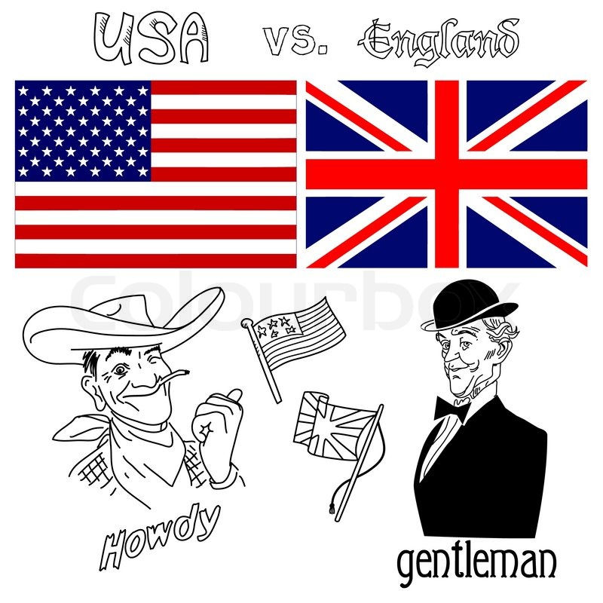
Highlight the correct word to fill in the sentence in order to form sentences that are said either by American or British persons. Each sentence contains a clue …

My friends are moving into their apartment in autumn/fall.
GB US Clue:

The lorry is parked on the parking lot/car park.
GB US Clue:

My trousers are in the closet/wardrobe.
GB US Clue:

I always eat sweets/candy during recess.
GB US Clue:

She was pushing a pram on the sidewalk/pavement.
GB US Clue:

He doesn’t like maize but he likes chips/fries.
GB US Clue:

He put gas/petrol in his truck.
GB US Clue:

It was autumn and the pavements/sidewalks were covered in leaves.
GB US Clue:

She changed her baby’s nappy/diaper and put it into the pram.
GB US Clue:

She opened a can/tin of sardines and ate it with fries she had made before.
GB US Clue:

HAVE FUN with British or American English

Highlight the correct word to fill in the sentence in order to form sentences that are said either by American or British persons. Each sentence contains a clue …

My friends are moving into their apartment in autumn/fall.
GB US Clue:

The lorry is parked on the parking lot/car park.
GB US Clue:

My trousers are in the closet/wardrobe.
GB US Clue:

I always eat sweets/candy during recess.
GB US Clue:

She was pushing a pram on the sidewalk/pavement.
GB US Clue:

He doesn’t like maize but he likes chips/fries.
GB US Clue:

He put gas/petrol in his truck.
GB US Clue:

It was autumn and the pavements/sidewalks were covered in leaves.
GB US Clue:

She changed her baby’s nappy/diaper and put it into the pram.
GB US Clue:

She opened a can/tin of sardines and ate it with fries she had made before.
GB US Clue:

