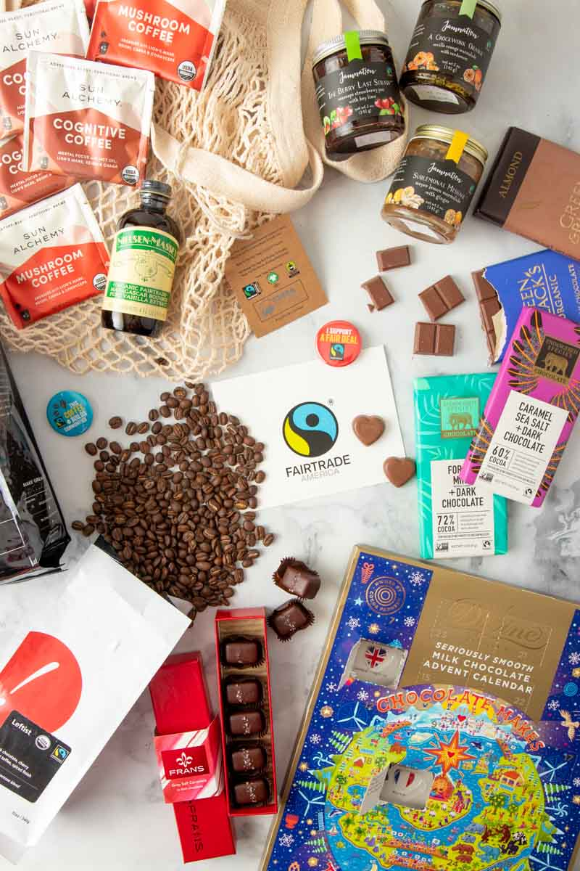
WHAT IS FAIR TRADE?

TASK 1: Watch the video 3 times, take notes and then, try to answer the following questions or finish the sentences

When buying products at the supermarket, what are the decisions we make based on?

-
-
-

Those decisions may have ____________________

What do fair trade products improve?

How does fair trade work?

- Farmers don’t
- They are members
- They are organized

Advantages of this system?

Name some available fairtrade products:

How many farmers worldwide work in the fairtrade business?

TASK 2: Read and guess the missing words

The Fair Trade __________________ now appears on a range of everyday items like coffee, face cream and even clothes. That means __________________ with a conscience can help people in __________________ countries every time they __________________ something.
Some shops have introduced a range of Fairtrade clothes made from __________________ cotton. This is produced without __________________, therefore it is advantageous for the cotton farmers and for the environment.
The farmers also benefit __________________ this ethical system because they get a __________________ for their work which will undoubtedly improve their lives. The Fair Trade clothes companies don’t use __________________so that youngsters can __________________ school and will never work in a toxic environment such as a __________________ factory.
Long story short, with Fair Trade, everyone gets __________________- shoppers can buy pure, natural products and growers can escape from long hours and low __________________.

TASK 2: Read and guess the missing words

The Fair Trade __________________ now appears on a range of everyday items like coffee, face cream and even clothes. That means __________________ with a conscience can help people in __________________ countries every time they __________________ something.
Some shops have introduced a range of Fairtrade clothes made from __________________ cotton. This is produced without __________________, therefore it is advantageous for the cotton farmers and for the environment.
The farmers also benefit __________________ this ethical system because they get a __________________ for their work which will undoubtedly improve their lives. The Fair Trade clothes companies don’t use __________________so that youngsters can __________________ school and will never work in a toxic environment such as a __________________ factory.
Long story short, with Fair Trade, everyone gets __________________- shoppers can buy pure, natural products and growers can escape from long hours and low __________________.

