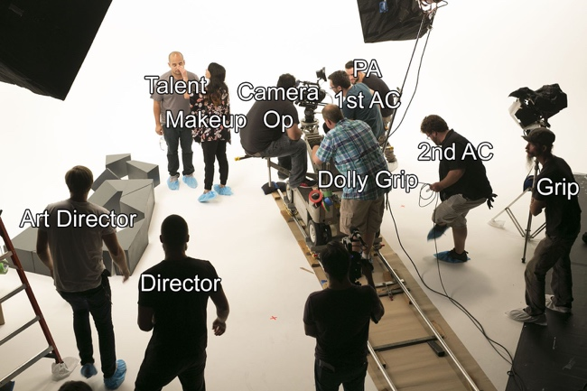
CO FILM CREW ROLES EXPLAINED (B2 level)
No images to help you this name
You are going to get information about 8 jobs…

- Your teacher will play the soundtrack of the “hidden” video 3 times.
- Try to get as much information as you can on a rough draft (in French or English)
- Recap the information you have found in the oral in French
- Work with a classmate or on your own to fill the following grid in English.

1st job  D ______________ | 2nd job  P_______________ | 3rd job  D___________________ | 4th job  C__________________
5th job  G_______________ | 6th job  B_________________ | 7Th job  S__________________ | 8th job  M_________________

Type of document:
Target audience:
Goal:

