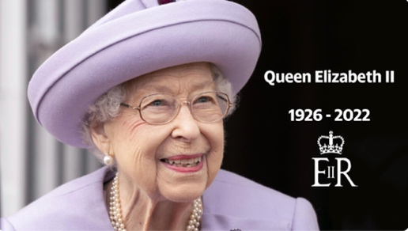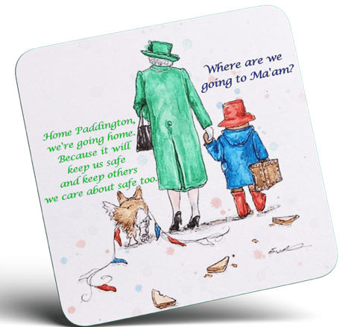 **Thank you Ma’am!**

Sadly, Queen Elizabeth II, aged 96,

**passed away** on

Thursday, September 8th 2022 at Balmoral Castle in Scotland.

Today, people worldwide are **overwhelmed by sadness and mourning their loss.**

All the flags will remain **half-mast** to **pay tribute** to the longest-reigning British **monarch**,

to this **remarkable** and **unwavering** woman.

According to her family, she was a **genuinely kind-hearted** and **devoted** woman.

Everyone will **recall** her for her unconditional love for dogs and horses, as well.

Her Majesty the Queen was the **embodiment of devotion** and **will be remembered** as an **unmissable** icon.

Her **funeral** will be held on Monday, September 19th at 3.30 p.m at Westminster Abbey in London and then, she will be **buried** in St George’s Chapel at Windsor Palace, next to her father King George VI and her **beloved** husband, Prince Philip.

Queen Elizabeth II was qualified as being “a rock” but she will also be remembered as being:

**fully human**

**committed**

**devoted**

**dedicated**

**kind-hearted**

**extraordinary**

**remarkable**

**compassionate**

**supportive**

**respectful**

**faithful**

**steady**

**tenacious**

**dutiful**

**diligent**

**selfless**

**enduring**

**unwavering**

Last but not least, she was a genuinely humorous woman.

**On Saturday, 73 years-old King Charles III paid**

**a moving tribute to his late beloved mother saying:**

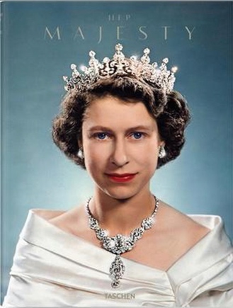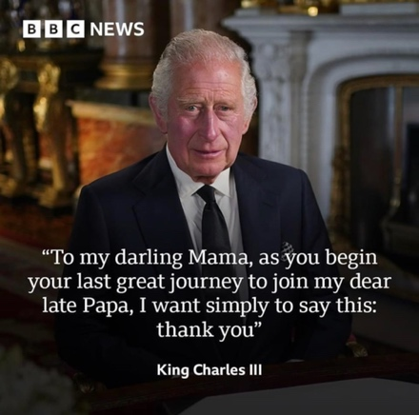

On Saturday, September 10th he was **proclaimed** King at

St James’s Palace, in a **solemn and moving ceremony** where he

**pledged an oath** and **took on his duty** officially.

**God save the King!**

A **pageantry** and his **coronation** will take place later…

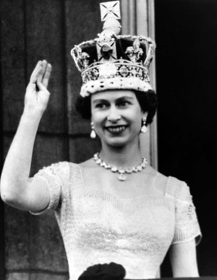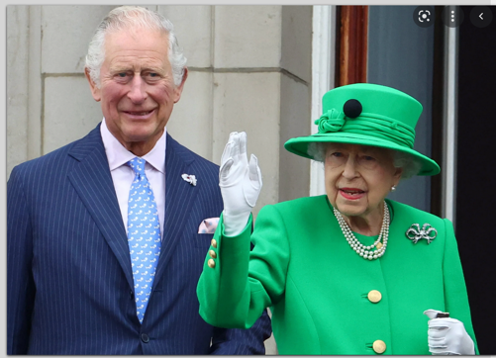

Learn more here: <http://florenceconrard.over-blog.com/2022/06/magic-queen.html>

**Thank you Ma’am!** **Vocabulary to remember**

|  |  |  |  |
| --- | --- | --- | --- |
| décéder |  | dévouée |  |
| Pleurer la mort de quelqu’un, être en deuil |  | empathique |  |
| Etre bouleversé |  | respectueuse |  |
| En berne |  | loyale |  |
| Rendre hommage à |  | altruiste |  |
| Un souverain |  | déterminée |  |
| Un couronnement |  | être d’un grand soutien |  |
| Une cérémonie à grand spectacle |  | constante, solide |  |
| proclamer |  | tenace |  |
| Se rappeler de quelqu’un |  | consciencieuse |  |
| Prêter serment |  | pleine d’humour |  |
| Assumer un devoir |  | au grand coeur |  |
| Être l’incarnation de |  | extraordinaire |  |
| Un enterrement |  | incontournable |  |
| enterrer, inhumer |  |  |  |

**Thank you Ma’am!** **Vocabulary to remember**

|  |  |  |  |
| --- | --- | --- | --- |
| décéder |  | dévouée |  |
| Pleurer la mort de quelqu’un, être en deuil |  | empathique |  |
| Etre bouleversé |  | respectueuse |  |
| En berne |  | loyale |  |
| Rendre hommage à |  | altruiste |  |
| Un souverain |  | déterminée |  |
| Un couronnement |  | être d’un grand soutien |  |
| Une cérémonie à grand spectacle |  | constante, solide |  |
| proclamer |  | tenace |  |
| Se rappeler de quelqu’un |  | consciencieuse |  |
| Prêter serment |  | pleine d’humour |  |
| Assumer un devoir |  | au grand coeur |  |
| Être l’incarnation de |  | extraordinaire |  |
| Un enterrement |  | incontournable |  |
| Enterrer, inhumer |  |  |  |