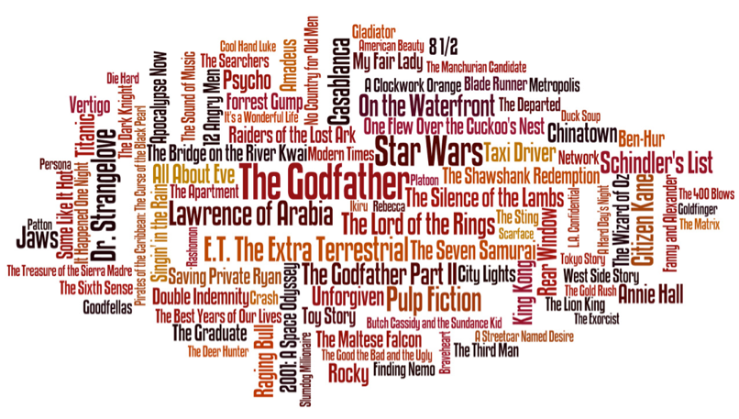
SPEAKING TIME / DEBATING

What is/are your favourite movie genres /ˈʒɒnrəz/?

What do you like in that genre?

MISSION 1: Start by ticking the movie genres you prefer
and crossing out the ones you particularly loathe

 a drama  an action movie  an animated movie
 a cartoon  an anticipation movie  a thriller
 a comedy  a romantic movie  a musical
 an adventure movie  a war film  a disaster movie
 a documentary  a historical film  a western
 a gangster film  a road movie  a horror film
 a mock horror film  a gore film  an epic
 a biopic /ˈbaɪəʊpɪk/  a science fiction film (sci-fi)  a short-film
 …

MISSION 2: Here are adjectives to support and enhance your answer.

- Take time to scroll the list and check if you can finish the following A2/B1 adjectives. You can add some more…
- Tricky mission now: look at the phonetics in the B2/C1 section and try to find the English equivalents
- Now, highlight the adjectives that match the best with your point of view…

A2/B1 vocabulary | B2/C1 vocabulary | English word | French translation
Bloo _ _  Bor _ _ _  Brut _ _  Comi _ _ _  Dar _  Disappoint _ _ _  Disgust _ _  Drama _ _ _  Enjoy _ _ _ _  family friend _ _  fascin _ _ _ _ _  feel-g _ _ _  hilar _ _ _ _  imaginat _ _ _  low-bud _ _ _  ordin _ _ _  origi _ _ _  pleas _ _ _  power _ _ _  remark _ _ _ _  satiric _ _  sensit _ _ _  sentiment _ _ _  surpri _ _ _ _  uninter _ _ _ _ _ _ | /əbˈzɔː^{r}bɪŋ/  /kliːʃeɪˈrɪdən/  /ˈdæzlɪŋ/  /dɪsˈteɪstfʊl/  /ˈdredfʊl/  /ˌfɑːstˈmuːvɪŋ/  /ˌfɜː^{r}stˈreɪt/  /ˈhaɪliˈtʃɑː^{r}dʒd/  /ˈɪnsaɪtfʊl/  /ɪnˈtriːgɪŋ/  /ˈdʒuːvənaɪl/  /mɔːˈrɒnɪk/  /ˈɒdbɔːl/ (slang)  /ˌaʊtˈdeɪtɪd/  /ˈrɪbˌtɪklɪŋ/  /ˈrɪvɪtɪŋ/  /ˌsɛkəndˈreɪt/  /ˈsɛnsləs/  /səˈspɛnsfʊl/  /ˈtɪəˌdʒɜːkɪŋ/  /ˌθɜː^{r}dˈreɪt/  /ˈθɔːtprəvəʊkɪŋ/  /ˈtaɪə^{r}səm/  /ʌpˈrɔːriəs/  /ˈwæki/ |  | captivant, fascinant  bourré d’idées reçues  impressionant  de mauvais goût  affreux, atroce  au rythme haletant  excellent, de premier choix  très tendu, électrique judicieux, intelligent  intrigant  enfantin, puéril  idiot, stupide  excentrique, original  vieillot, désuet  à mourir de rire  fascinant, captivant médiocre  insensé, absurde  plein de suspense  émouvant, mélodramatique de très mauvaise qualité  qui invite à réfléchir ennuyeux  hilarant  dingue, barré, farfelu

