Who’s who in the film crew?
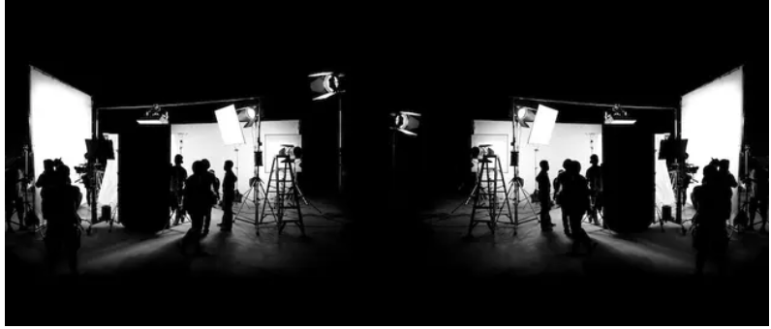

At its /ˈkɔː/ ____________________, filmmaking and video production is a highly /kəˈlæbərətɪv/ ____________________ process.
From Los Angeles to Metz , to locations around the world, the film industry /rɪˈlaɪz/ _________________ on film /ˈkruːz/ ________________ with a wide /əˈreɪ/ _________ _________ of skills.
/dɪˈrɛktə^{r}/ ____________________, producers, writers, /ˌsɪnɪməˈtɒgrəfə^{r}z/ ____________________, /ˈkæmərə ˈɒpəreɪtə^{r}z/ ____________________, /ˈkɑːpɪntəz/ ____________________, /ɪlɛkˈtrɪʃ^{ə}nz/ ____________________, and a wide range of designers are among the professionals you will find on a professional film crew.

The Film Production Process
Help section: •involved •postproduction •comprises • schedule •blockbuster •beginnings •process •production •accident •depending on •scope •nicknamed •preproduction

It's no _____________________ that the business of movie making is _____________________ "The Industry" in Hollywood. From its _____________________ in the studio system, film making has been an industrial _____________________.
It _____________________ three main phases: _____________________, ______________________ (principal photography), and _____________________.
Different people are _____________________ at different points of the production (UK:/ˈʃɛdjuːl/, US: :/ˈskɛdjuːl/) _____________________, which can take weeks, months or years, ___________________the size and _____________________ of the movie. A crew can be a couple of dozen people for a small, independent film, or thousands for a major Hollywood _____________________.

Vocabulary to remember
 | à la base |  | dépendre de
 | un procédé |  | être surnommé
 | une étendue, un objectif |  | se composer de
 | un planning, un calendrier, un agenda, un programme (de travail) |  | être impliqué dans
 | une équipe de tournage | EXTRA VOCABULARY
 | chef opérateur, directeur de la photographie + ( dans les films : cameraman, cadreur) | *According to schedule
 | un cadreur, cameraman | * on schedule = with no delay
 | un menuisier | * a show schedule
 | un réalisateur | credits
 | un éventail de compétences, une palette de compétences | Idiom : give credit where it’s due
 | une superproduction, un grand succès

Above the Line vs. Below the Line
The industry divides crew members into two categories: so-called "above the line" and "below the line."
Above the line people are those with the highest level of power, the ones who have authority over the production. They include principals in the production company, producers, writers, the director, and the principal talent (actors or stars). Needless to say, they earn the most money. Below the line workers are everyone else in the production crew, generally divided by profession into departments. Their compensation and working conditions are generally governed by union contracts.

3 Types of Film Production Jobs
When it comes to film production, jobs in the motion picture industry fall into three categories: preproduction, production, and postproduction.
- Preproduction is the stage that occurs before actual filming. Preproduction involves finalizing the shooting script, selecting locations, figuring out the production budget, assembling the creative team, and casting actors.
- Production is the stage of actual filming. Actors perform on camera, camera crews capture the action, lighting crews illuminate the set, sound crews capture audio, and creative designers oversee costumes, makeup, props, and scenery. The director oversees the entire operation.
- Postproduction occurs after filming is complete. The postproduction process involves editing footage, creating sound effects, composing an original score, sourcing existing songs, and cutting a trailer.

