WHAT IF…?

Have you already seen these logos? What do they represent?
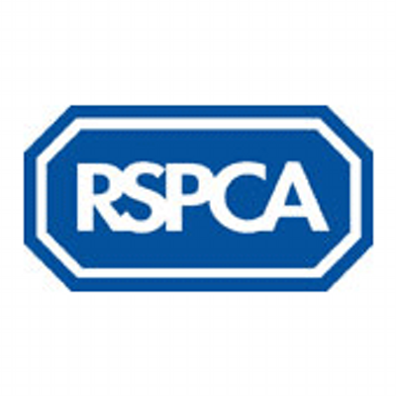
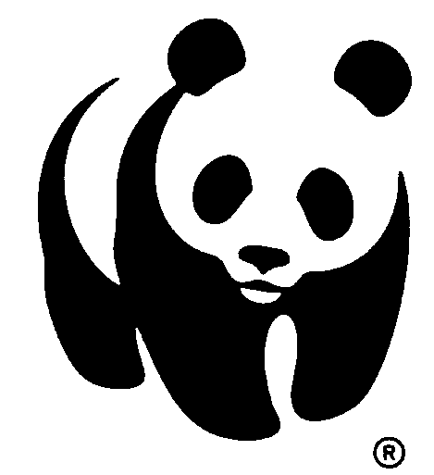

Listen to the 1st part of the video and complete the gaps
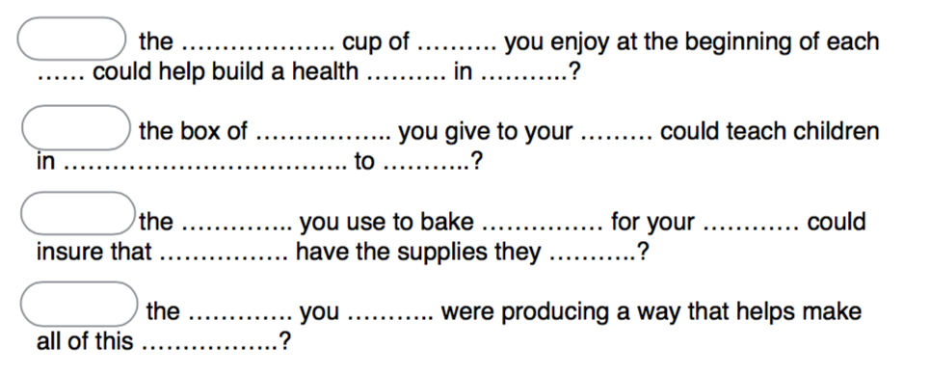

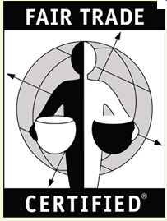
Listen to the 2nd part of the video and list the 5 ADVANTAGES of buying Fair Trade products
When you buy Fair Trade products,

1.
2.
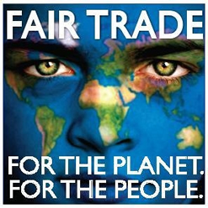
3.
4.
5.
Listen and finish this sentence : Behind every fair trade certified labels …..

CATCHPHRASE : _ _ _ _ _ _ Fair trade _ _ _ _ _ _ _ _ _ products because every _ _ _ _ _ _ _ _ matters.
WHAT IF…?

Have you already seen these logos? What do they represent?

Listen to the 1st part of the video and complete the gaps

Listen to the 2nd part of the video and list the 5 ADVANTAGES of buying Fair Trade products
When you buy Fair Trade products,

1.
2.
3.
4.
5.
Listen and finish this sentence : Behind every fair trade certified labels …..

CATCHPHRASE : _ _ _ _ _ _ Fair trade _ _ _ _ _ _ _ _ _ products because every _ _ _ _ _ _ _ _ matters.

