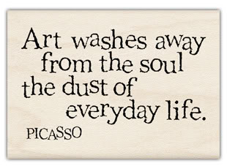
ART…

“Art is powerful. Art is meaningful. It enriches our society”. Keith Bond (Fine Arts Artist)
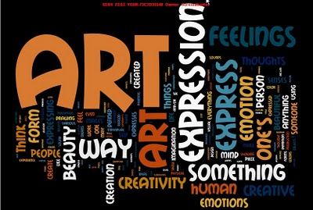

MISSION 1: What types of Art do you know? With the help of your classmates, fill in the grid in English.

Une peinture |  | Une gravure sur bois
Un autoportrait |  | La mosaïque
Une nature morte |  | La poterie
Un croquis |  | La sculpture
Une bande dessinée |  | La céramique
Un dessin humoristique |  | La photographie
Un dessin |  | L’architecture
Une gravure |  | Le design (objets, vêtements…)
L’art de la rue |  | L’art numérique
Les beaux-arts |  | La musique
Les arts graphiques |  | Le cinéma
Les arts appliqués |  | Le théâtre

MISSION 2: 1. Write a short definition on a piece of paper… What is Art for you? (30 words)

2. Which one(s) is/are your favourite and why? (Use the tool box to justify)

TOOL BOX: fascinating, enthralling, necessary, useful, helpful, creative, interesting,

powerful, meaningful, expressive, moving, touching, stirring, affecting…

MISSION 3: Complete your teacher’s definition of Art

Everyone has his/her own idea of what Art is and (en ce qui me concerne) ___________________________, Art is a way to express ourselves, (de s’échapper du monde réel)_______________________________________, to create our own world.
(A mon avis) ____________________, Art (n’a pas forcément besoin d’être) ____________________________________
_________________(esthétique) _____________________ /iːsˈθɛtɪk/, (cependant) ___________________, it has to be (plein de sens, éloquent) ___________________, (subtile) _______________ and (émouvant) ____________________.
Art (reflète) ____________________ our identity, our personality. It (n’a pas de limites) _____________________ and can take different forms.
Art is (comme un rêve qui se réalise) __________________________ when you (réussir à) _____________________ (gagner sa vie) ________________________ from it.
Art is (complètement exceptionnel)__________________________!

