London's skyline recreated with fruit

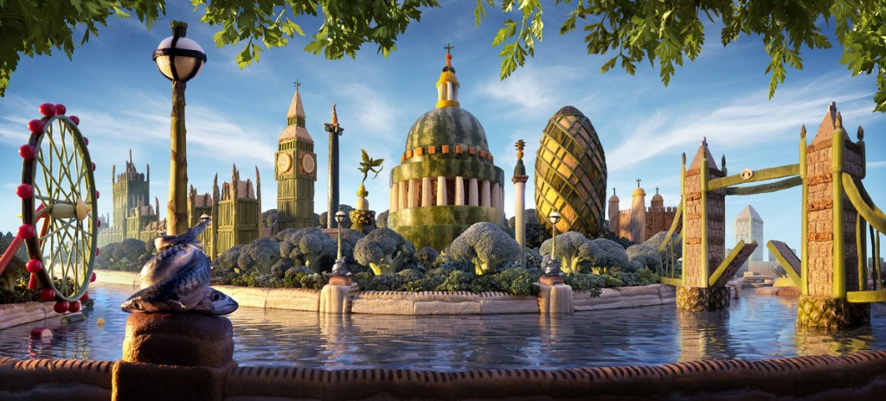
London's skyline has been recreated using fruit as part of a promotional campaign.

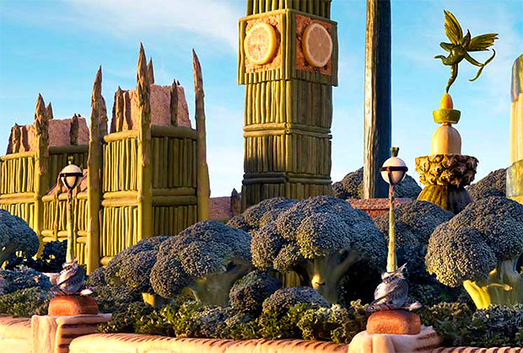
Carl Warner and a team of five model makers spent three weeks crafting the scene using hundreds of pieces of fruit and veg - all painstakingly glued together.
The Houses of Parliament are built from a mix of asparagus, green beans and runner beans which are mixed with baby sweet corn to depict the intricate stonework.
The Gherkin, found in the Square mile, is cunningly crafted out of two types of melon and embedded with green beans to highlight its renowned spiralling glass frames.
While Nelson's column is cleverly constructed from a cucumber, baby courgettes and a carrot with a monkey nut and almond stuck on to it.

Other high profile London landmarks given a makeover include The London Eye which has green beans as spokes and its pods made out of baby plum tomatoes.
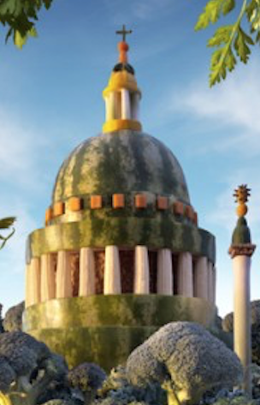
The spire on St Paul's Cathedral, has been given a fruity new look, after the spire was created from roundels of carrot, yellow and green courgette and baby leeks.
The famous dome designed by Christopher Wren in the 17th century, has been made using a melon, while the impressive columns have been crafted out of baby sweet corn.
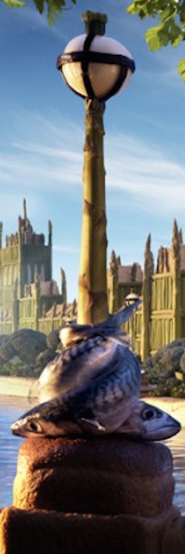
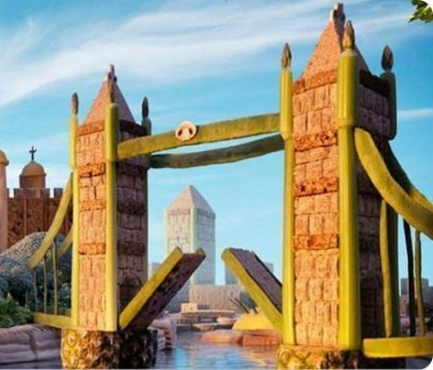

It even features the Thames-side lamp posts which are made from onions wrapped in vanilla pods for the lamps, asparagus for the posts and mackerel for the ornate fish plinths.

Roopa Gulati from the Good Food channel, the company who commissioned the work, said the image represents how fruit and vegetables can be used imaginatively in the diet.
He said ''This stunning image which has quite literally transformed the London skyline with good food proves that fun with food in a creative and light-hearted way is the way forward''.
MISSION 1: Read and find out the English names for this food

Un concombre |  | Une cacahuète
Un poireau |  | Une amande
Un oignon |  | Du maïs doux
Une asperge |  | Des haricots d’Espagne
Une courgette |  | Des haricots verts
Une tomate italienne |  | Des gousses de vanille
Du maquereau

MISSION 2: Try to find the words linked to architecture… All of them are in the text…

/ˈskaɪˌlaɪn/ |  | Un horizon, une silhouette d’immeubles
/ˈstəʊnˌwɜːk/ |  | un édifice en pierre
/glɑːs freɪm/ |  | Une charpente en verre
/ˈmeɪkəʊvəʳ/ |  | une rénovation
/spəʊk/ |  | un rayon
/pɒd/ |  | une nacelle
/spaɪə/ |  | une flèche, pinacle d’un bâtiment (architecture)
/dəʊm/ |  | une coupole
/ˈkɒləm/ |  | un pilier
/plɪnθ/ |  | un socle

MISSION 3: Name the places in this London skyline…

1 | 2 | 3 | 4 | 5
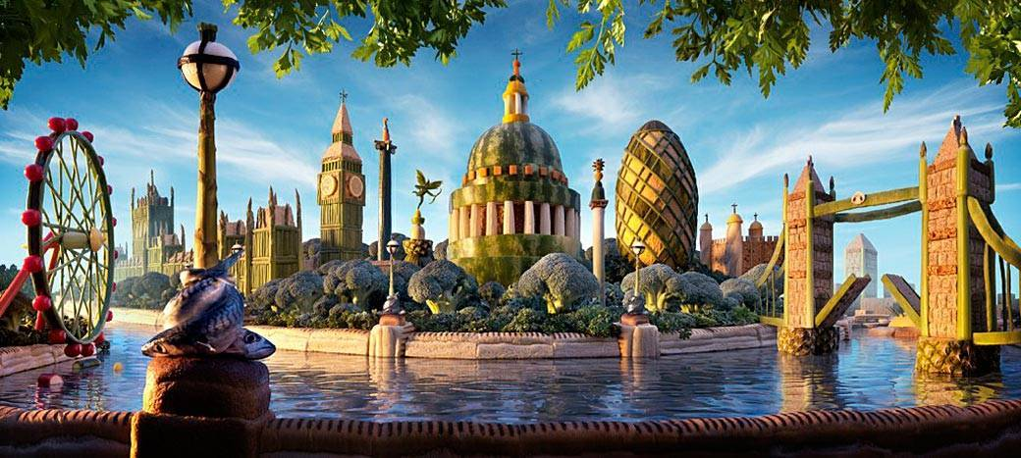
6 | 7 | 8 | 9 | 10
Why was this skyline created?

