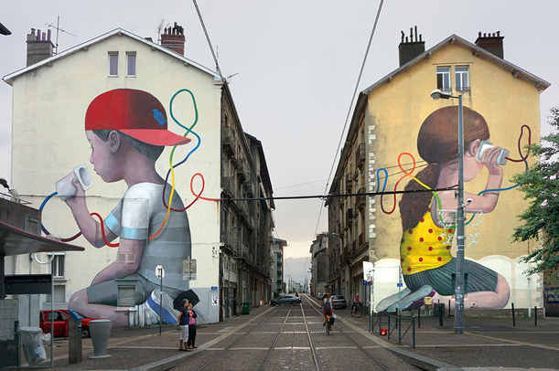

THE ORIGINS OF GRAFFITI and STREET ART

LOOK AT THE POWERPOINT,
TRY TO REMEMBER AS MANY THINGS AS POSSIBLE then, ANSWER THE QUESTIONS

1. THE ORIGINS OF THE WORD GRAFFITI /ɡrəˈfiːti/
It comes from the ____________________, which means to__________ and __________.
This was initially used by ___________________to describe ________________, __________________, ____________________ OR ____________________ found in _____________________________, in ancient buildings in Pompeii, Egypt and in the Roman catacombs.
2. DEFINITION
Graffiti: Images, lettering or drawings ___________________(gribouillés), ______________________(grattés), or spray- painted __________________ on a wall or other surface in a _______________________.
3. MOTIVATION FACTORS:
- Self-___________________
- Sharing _________________________________
- R______________________
- P______________________
- F______________________

4. EQUIPMENT
Street artist usually use P________, c_____________, s________________, m_____________ pens, s_________________ (pochoirs), etc...
5. TYPES OF GRAFFITI
- _______________________________
- _______________________________
- _______________________________

