DN MADE 1 Edition & Image

BRAZILIAN WAX MUSEUM

Click on the following link:

https://news.artnet.com/art-world/brazilian-wax-museum-1936826
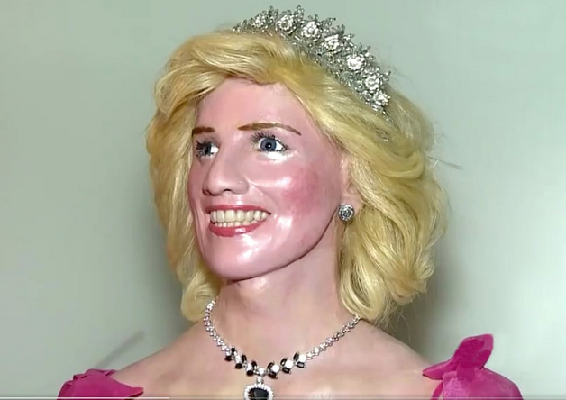
Read the article and make an account of it in about it in English.
- Start with the presentation (type, source, date, author, title).
- Summarize the content of the article (do not copy the sentences from the article but account for the prevailing information).
- Conclude by saying which public is targeted and explaining the journalist’s goal.
- Give your opinion about this article.

Send me your work back at: conrard.florence@gmail.com

àDN MADE 1 Edition & Image

BRAZILIAN WAX MUSEUM

Click on the following link:

https://news.artnet.com/art-world/brazilian-wax-museum-1936826
Read the article and make an account of it in about it in English.
- Start with the presentation (type, source, date, author, title).
- Summarize the content of the article (do not copy the sentences from the article but account for the prevailing information).
- Conclude by saying which public is targeted and explaining the journalist’s goal.
- Give your opinion about this article.

Send me your work back at: conrard.florence@gmail.com

