Will you get Banksy-ed?
Key question: How do Banksy’s works of art constantly question art?
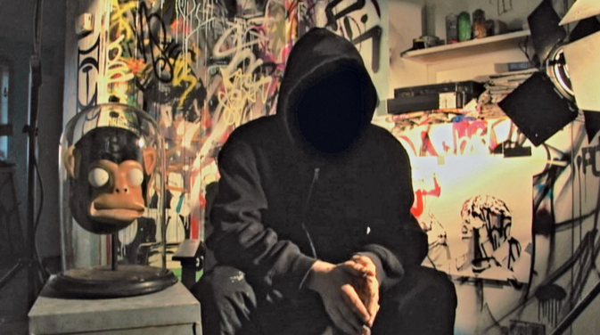
MISSION 1: A secret Identity
- Look at the still and describe it. What do you know about this man?
- Listen to the audio on the blog and pick out information about Banksy and his various activities.
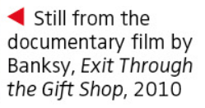
- Find out where we can usually see his artworks and explain the quote: “The world is his canvas”
- What is Banksy’s opinion on the sale of his works of art?

THINGS TO REMEMBER

Banksy is an unknown British graffiti artist. He is believed to be a native of Yate, near Bristol, England. His artworks are often satirical pieces of art on topics such as politics, culture and ethics. His street art which combines graffiti writing with a stenciling technique, is similar to Blek Le Rat, a French street artist who began to work with stencils in 1981 in Paris.

Will you get Banksy-ed?
Key question: How do Banksy’s works of art constantly question art?
MISSION 1: A secret Identity
- Look at the still and describe it. What do you know about this man?
- Listen to the audio on the blog and pick out information about Banksy and his various activities.
- Find out where we can usually see his artworks and explain the quote: “The world is his canvas”
- What is Banksy’s opinion on the sale of his works of art?

THINGS TO REMEMBER

Banksy is an unknown British graffiti artist. He is believed to be a native of Yate, near Bristol, England. His artworks are often satirical pieces of art on topics such as politics, culture and ethics. His street art which combines graffiti writing with a stenciling technique, is similar to Blek Le Rat, a French street artist who began to work with stencils in 1981 in Paris.

