AXE 6 : La création et le rapport aux arts ART EVERYWHERE
Key question: How can art on the street broaden our horizons?

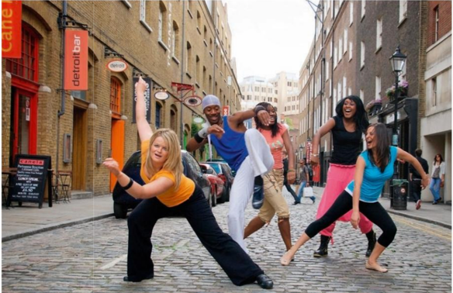
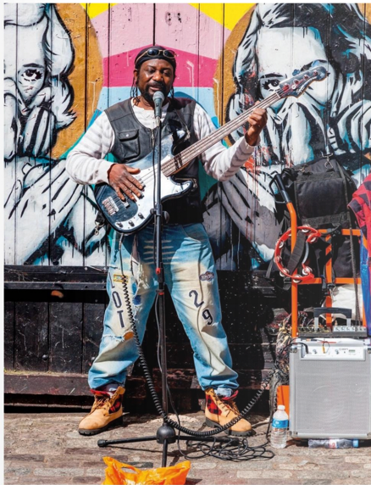
INTRODUCTION: Let's take a stroll (Allons flâner...). Have a look at the photos on the blog.
Photo 1: Street Entertainer, Brick Lane Market, London

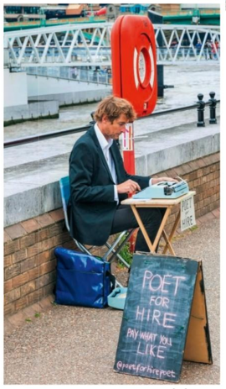

Photo 3: A group of dancers performing on Earlham Street, outside Cambridge Theatre, London
Photo 2: Poet for Hire, Southwark, Bankside, London
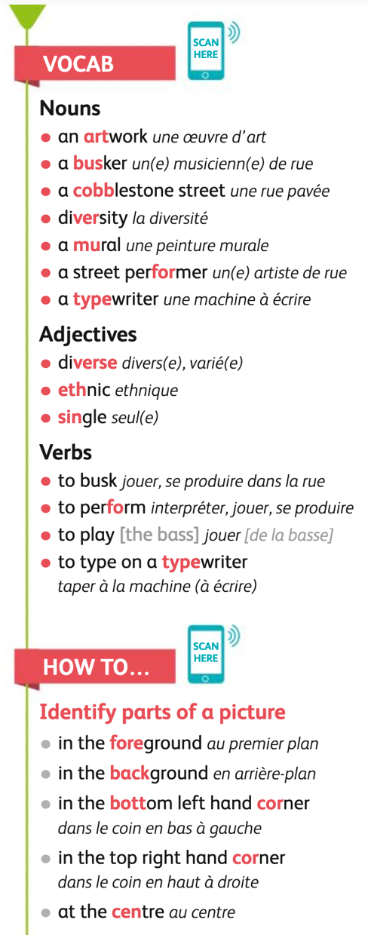

Mission 1: SPEAKING TIME
- Look at the 3 photographs, describe the people and their activities.
Use the word bank on your right
- What is common to all 3 photos?
- Which form of art do you prefer? Justify.
Mission 2: RECAP
In the 1st photo, (un musicien de rue joue de la basse) ________________ ___________________________and singing into his microphone. (A l’arrière plan), ____________________________, (il y a une fresque colorée) _________ _____________________________ which (représente, illustre) _______________ two women. This photo thus shows two art forms (qui interagissent) ________ _____________________________.
In the 2nd one, a poet (vêtu d’un costume bleu) _________________________ is typing a poem on his (machine à écrire) __________________. The message on the (pancarte) ________________________ is crystal clear: this poet is (à louer) _____________________ which means anyone can hire him to write a poem and you can give him a (pourboire)____________ if you appreciate his work.
In the last one, a dance company is dancing (au milieu de) ________________ a (rue pavée) _______________________________.
The 3 pictures show diverse forms of art (jouées dans les rues de Londres) ________________________ __________________. Arts (tels que) _________________ music, poetry and dance are all (mélangées ensemble) _________________________________________ and show (la diversité artistique mais aussi culturelle) __________________________________________ of London.

