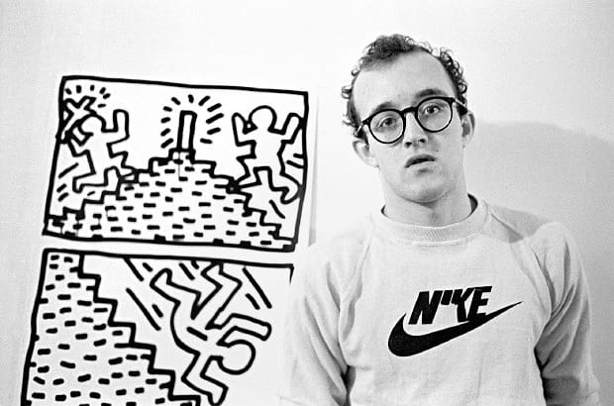
KEITH HARING
How does Art mirror our society?
MISSION 1:
Read the introduction above and click on the link : https://www.haring.com/!/about-haring/bio
Recap the main information about Keith Haring and be ready to share them with your class in the oral.

His work started on the streets
Keith Allen Haring was born May 4, 1958 in Reading, Pennsylvania and died February 16, 1990 in New York City. Keith Haring was a popular artist and activist who was part of the legendary New York art scene during the 1980s. While he is known for his colourful works and his iconic motifs such as the radiant baby* and the barking dog*, much of his work responded to contemporary social and political events. This included the battle to end Apartheid, the AIDS epidemic and drug abuse. As an openly gay artist Haring also chose to represent the hardships of the LGBTQ community in his work, including gay rights. Inspired by graffiti artists he began drawing in New York’s subway stations; filling empty poster spaces with chalk drawings which people would walk past every day. His aim was to make art accessible to everyone and these works allowed him to interact with a diverse audience.
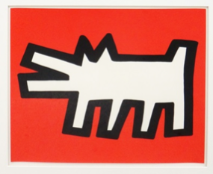
“All kinds of people would stop and look at the huge drawing and many were eager to comment on their feelings toward it. This was the first time I realized how many people could enjoy art if they were given the chance. These were not the people I saw in the museums or in the galleries but a cross-section of humanity that cut across all boundaries.” Keith Haring
*The Barking Dog has become one of Haring's most iconic symbols, first appearing in his New York subway drawing series from 1980–85. It emerged as a symbol of oppression and aggression, acting as a warning to the viewer of the abuses of power that pervade everyday life in America and beyond.

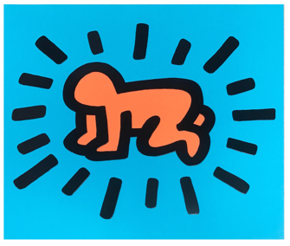
*Keith’s pictogram of "the Radiant Baby". It becomes his signature. The rays around the baby represent his energy, this pictogram thus symbolizes life, joy and hope for the future.

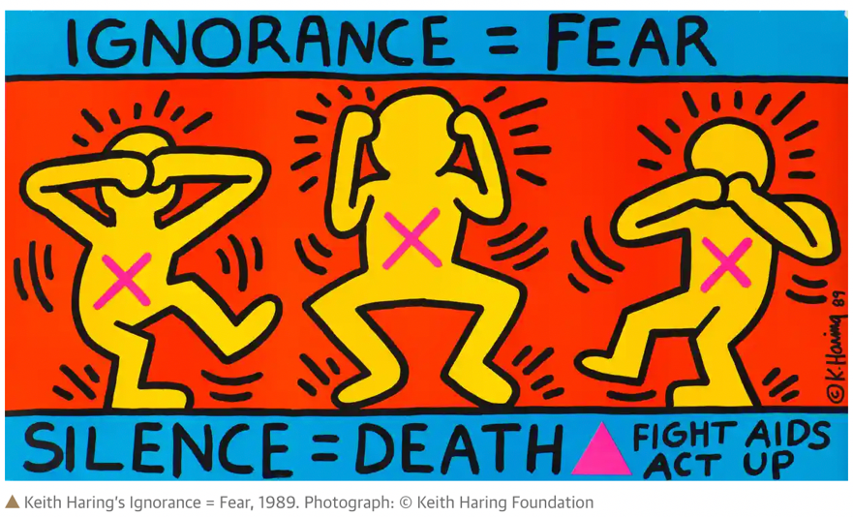

MISSION 2:
Look at the following artwork by Keith Harring.
- Introduce it briefly
- Describe it
- Say what message it conveys

