STREET ART TELLS US ABOUT THE WORLD
EDPUZZLE: Log on your account and listen to the video about Banksy.
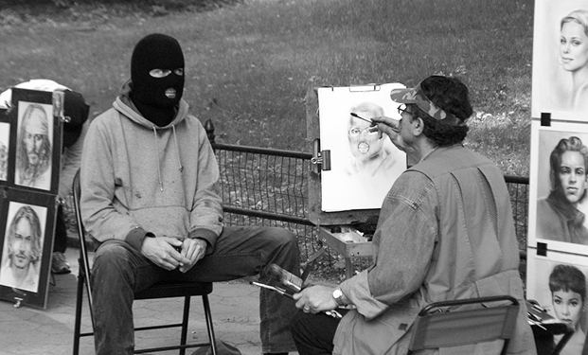
MISSION 1: What do you know about this man?
Banksy is an anonymous British street artist, vandal, political activist, and film director, active since the 1990s. He was most probably born in Bristol in 1974. His works of political and social commentary aim at denouncing and raising awareness of serious issues such as global warming, wars, politics or capitalism and are displayed on streets, walls, and bridges of cities worldwide.
His public "installations" are regularly resold, often even by removing the wall they were painted on and Banksy has now become a legend!

STREET ART TELLS US ABOUT THE WORLD
EDPUZZLE: Log on your account and listen to the video about Banksy.
MISSION 1: What do you know about this man?
Banksy is an anonymous British street artist, vandal, political activist, and film director, active since the 1990s. He was most probably born in Bristol in 1974. His works of political and social commentary aim at denouncing and raising awareness of serious issues such as global warming, wars, politics or capitalism and are displayed on streets, walls, and bridges of cities worldwide.
His public "installations" are regularly resold, often even by removing the wall they were painted on and Banksy has now become a legend!

