AXE 2 : Private and public space/sphere WOMEN OF PROHIBITION

Be logical and complete the following introduction with the given vocabulary

have evolved / male-dominated / were restricted / though / has been difficult for / have had to fight

For centuries, women ______________________ to the domestic (private) sphere.
And ___________________ our western societies ______________________,
it _______________________________ women to enter the public sphere.
They ______________________ to gain recognition and more rights in a ______________________ society.

Key question: How did American women’s place in society change with Prohibition?

Mission 1: Cultural Background
Read the Cultural file on Prohibition on the blog and try to complete the missing elements.

Prohibition in the USA lasted for _________________________ from ________________ to 1933.
During this paradoxical period, ________________ couldn’t be __________________________, _________________________ or ________________ which means it was ________________ but the fact of ________________ alcohol was not mentioned in the ban.

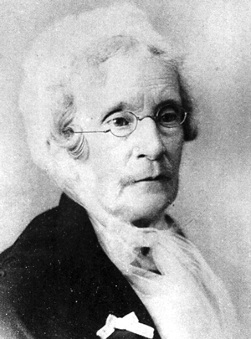
Eliza Thompson (1816-1905)

an advocate = a defender, a militant
to advocate = to promote, to encourage

As a member of the WCTU ( __________________________________), Eliza Thompson’s aim was to ______________________________________alcohol.
She _______________ a crusade ____________ alcohol in saloons where she __________________ and __________________________ of the establishments with other female advocates.

Changes in The Roaring 20s (The Jazz Age) are synonymous with _ _ _ _ _ _ _ _ _ _.
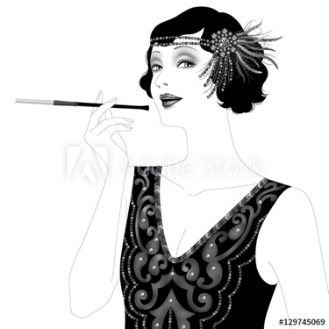
the upsurge= the increase
a flapper = une garçonne
a speakeasy = un bar clandestin
to usher in = announcer, entrer dans

- Growth of ……………………………………..
- Rise of ………………………………………...
- Increase of …………………………………….
- Revolution in ……………….: sexual codes, gender roles
- Revolution in manners: Women’s …………………… and dresses …………………...

The word “flappers” was introduced and corresponded to ………………………….. with a short “bob” hairstyle, a cigarette ………………………. their painted lips, drinking in …………………….. and …………………… to a live jazz band.

IMPORTANT landmarks ( = ……………………………….) to remember:

19 _ _ : Ratification of the _ _th Amendment to the Constitution which …………………the production, sale, transportation, importation or exportation of alcohol.
19 _ _ : Ratification of the _ _th Amendment to the Constitution which ……………………………….to vote for women in the USA. (thanks to the NAWSA, the National American Woman Suffrage Association)

Give a definition of a Speakeasy:

……………………………………………………………………………………………………………………………………………………………………………………………………………………………………
…………………………………………………………………………………………………………………

a den = une tanière/un repaire (illegal place)
patrons = customers from a bar in the 20s

The term SPEAKEASY comes from the fact that customers had to whisper (to speak “easy) when entering the hidden and illegal bar, not to be noticed.

CONCLUSION: Complete with the appropriate tense

During the 20’s, women (ont renversé) …………………………………... social conventions and (sont descendues) ……………………………………. the streets to fight for the suppression of alcohol, (pour s’élever contre l’inégalité des sexes) …………….…………………………………… and thus, gained liberation.
The women of Prohibition (ont changé l’Amérique pour toujours) …………………………………….
……………………………………………………. .

HELP SECTION: To upturn = renverser
To take to the streets = descender dans la rue
To speak out against = dénoncer
Gender inequality/gender gap = l’inégalité des sexes

