Doc 3: Volunteers
https://www.aquariumofthebay.org/volunteers/
- Read the homepage of this website. Imagine what may attract people to work at the Aquarium of the Bay.
- Read the short text “Volunteers” and identify its nature. Summarize the content.
- Read Jeff’s cover letter and explain why he applies for that job.
- Pick out adjectives that characterise Jeff. Explain why he would be a good candidate.

----------------------------------------------------------------------------------------------------------------------------------------------
HOMEWORK:
Task 1: Go on the website: https://www.monster.ca/career-advice/article/50-personality-traits-for-the-workplace-canada
Read the list of adjectives proposed and select at least 5 adjectives that correspond the best to your qualities and personality. Write them down in your copybook and write the corresponding definition.
Task 2: Go on the website https://www.aquariumofthebay.org/volunteers/ a. Discover the section Volunteer requirements and complete the following information:
How long is the contract:
Required skills:
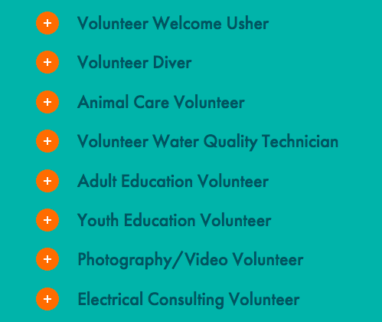
Age requirement:

b. ORAL EXPRESSION: Read the information about the possible jobs, choose one and be ready to present it to you class (1 to 2 minutes).
1. Choose a job from the list
2. Say what it consists in
3. Say what skills are required
4. Say why you would be a good candidate for this job
5. Say why you have chosen this job.

