B1/B2 Test your vocabulary skills Personality adjectives
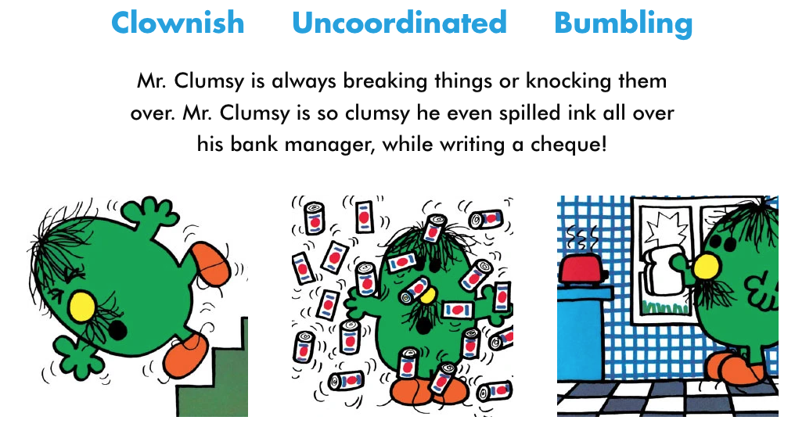

My score:

_________/20

Mission 1: Take the following quizzzzzzzzz…

- I am always delighted. I am _________________________.
a. grateful b. lousy c. cheerful

- I always want to know everything about everybody. I am _________________________.
a. noisy b. aloof c. nosy

- I talk openly. I am _________________________.
a. dishonest b. frank c. even-tempered

- I am careful. I am _________________________.
a. compassionate b. cautious c. handy

- I never complain and I’m kind. I am ___________________________.
- easy-going b. stubborn c. stingy

- I often lose things. I am _________________________.
a. gullible b. deceitful c. forgetful

- I have no worries. I am ________________________.
a. carefree b. careless c. cunning

- I wish I had more friends. I am _________________________.
a. lonely b. lovely c. gentle

- I am very active. I am _________________________.
- thrifty b. blunt c. lively

- I am not strong and tough. I am _________________________.
a. resentful b. gentle c. weird

- You can trust me! I am _________________________.
a. reliable b. articulate c. outgoing

- I speak and express myself well. I am _________________________.
a. quirky b. articulate c. ambitious

- I am not shy at all. I am _________________________.
a. modest b. outgoing c. passive

- I get angry quite easily. I am _________________________.
a. clumsy b. bold c. short-tempered

- I am confident and bold. I am _________________________.
a. assertive b. moody c. arrogant

- I don’t like to show off. I am _________________________.
a. ambitious b. modest c. outgoing

- I have strange habits. I am _________________________.
a. frank b. quirky c. trustworthy

- I always knock into things and make a mess. I am _________________________.
a. conceited b. carefree c. awkward

- I am carefree and a little lazy. I am a _________________________.
a. jock b. slacker c. geek

- I love sports. People call me a _________________________.
a. jock b. geek c. slacker

