AXE 7: DIVERSITY & INCLUSION BEING AMISH IN THE 21st CENTURY

Key question: How does an age-old community face 21st century challenges?

BRAINSTORMING
After returning from Sunday church an Amish family walks with bare feet over a country road in the heart of rural Lancaster County, Pennsylvania, on 24 June, 2018.
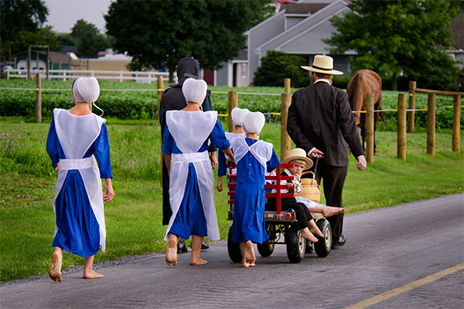
HELP BOX :
Amish /ˈɑːmɪʃ/,
lifestyle = way of life
old-fashioned = outdated
plain = simple, traditional
headdress = bonnet /ˈbɒnɪt/
to walk barefoot = to walk with no shoes on
to live with the bare necessities = to live a very simple life.

MISSION 1: Introduce this document and describe it. Use the help box to make your sentences.

INTRODUCTION: An Age-Old Thriving* Community

The USA is filled with endless diversity, people of all colours, religions, ethnicities and cultures come together in one giant landmass. And the centre of this diversity is the Amish, a group of people who follow a traditional Christian Church derived from Swiss Germany.

To thrive* = prospérer, être florissant

MISSION 2: Listen to this video (without watching): Who are the Amish? Take notes and recap the information you got to your class in French.

MISSION 3: AT HOME: Now watch the video on the blog, have a look at this questionnaire and try to find the correct answers

1. The report is about an Amish community who lives in...
a. Swiss Germany b. Lancaster County, Pennsylvania c. Lancaster Country.

2. True or false? Tick the correct answer and justify with keywords.

☐ True ☐ False It is quite difficult to have images of the Amish.

Justify:

☐ True ☐ False The Amish generate their own electricity.

Justify:

☐ True ☐ False The Amish migrated to Pennsylvania in the 17th century.

Justify:

☐ True ☐ False The Amish live like people did centuries ago.

Justify:

☐ True ☐ False The Amish children go to public schools.

Justify:

3. Name three values that define the Amish community.

a. simple ________________ .
b. _______________ dressing.
c. _____________________ modern technologies.

4. List the three things the Amish are not allowed to use in their everyday life.

1. ___________________ 2. _____________________ 3. ____________________________

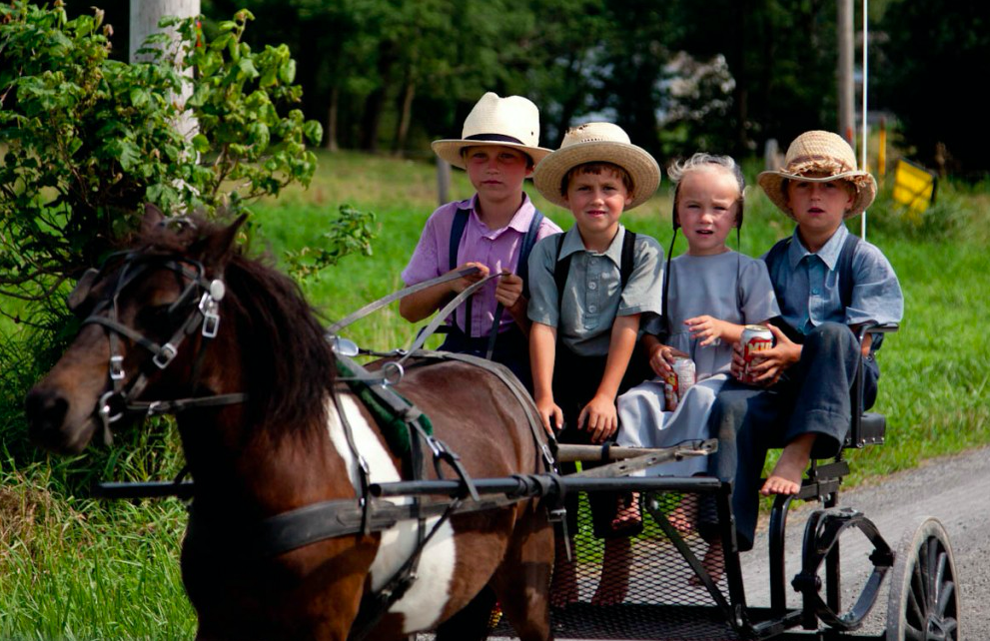
5. What do these figures refer to?

15%:
300,000:
8 and a half:
30%:
95-100%:

- What jobs are the Amish mostly choosing (in the order of the report)?

a. ____________________
b. home ___________________
c. _________________
d. barn ________________
e. __________________________
7. "If they fail to comply, they are shunned (to shun= ………………………..)." means...
- □ If the Amish refuse to live by the rules of the community, they will be sent to prison.
- □ If the Amish refuse to live by the rules of the community, they will be reprimanded.
- □ If the Amish refuse to live by the rules of the community, they will be sent away.

