AXE 7: DIVERSITY & INCLUSION RUMSPRINGA
Living or Leaving the Amish Life
Key question: How far do the Amish have to adapt to the modern world to preserve their lifestyle and traditions?
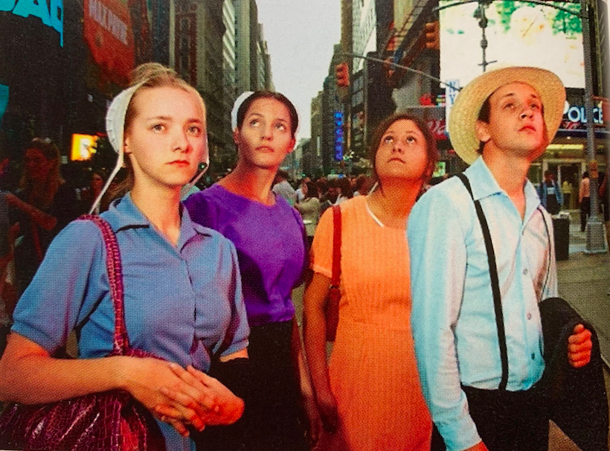
WARM-UP:
- Observe this photo and describe it briefly
(people, place, situation, feelings…)
- To what extent is this photo unusual?
- Make suppositions : Why do you think they
are in NY city?

MISSION 1: Read this article and find out what Rumspringa is :
https://amishamerica.com/what-is-rumspringa/
Then, complete the following summary:
•baptized member •live English  •a great deal of freedom •to make •lasts •sixteen •prefer to return •would rather •decision •outside •to run around •Rumspringa •leaving •experience •experience the outside world
The term ____________________________________/rəmˈsprɪŋə/, meaning « ____________________________________ » is used to describe the period that young Amish ____________________________________ around the age of _______________________. It comes from the Pennsylvania Dutch word “Rumspringen”.
At that age, Amish teens are given ____________________________, which they can use to ______________________________. Some may even choose to « ____________________________________ », the term “English” meaning anyone living ____________________________________the Amish community.
Sometimes it ____________________________________a year, sometimes it’s eighteen months, two years, but at the end of that time period, then it’s ____________________________________time. “Are you staying and becoming a full member, ____________________________________ of the church, or are you ____________________________________? That’s a huge decision that every Amish person has ____________________________________. »
After Rumspringa, most teenagers ____________________________________ to the full Amish lifestyle and they are thus baptized and become full members of the Amish community. Others ____________________________________ leave the community.

