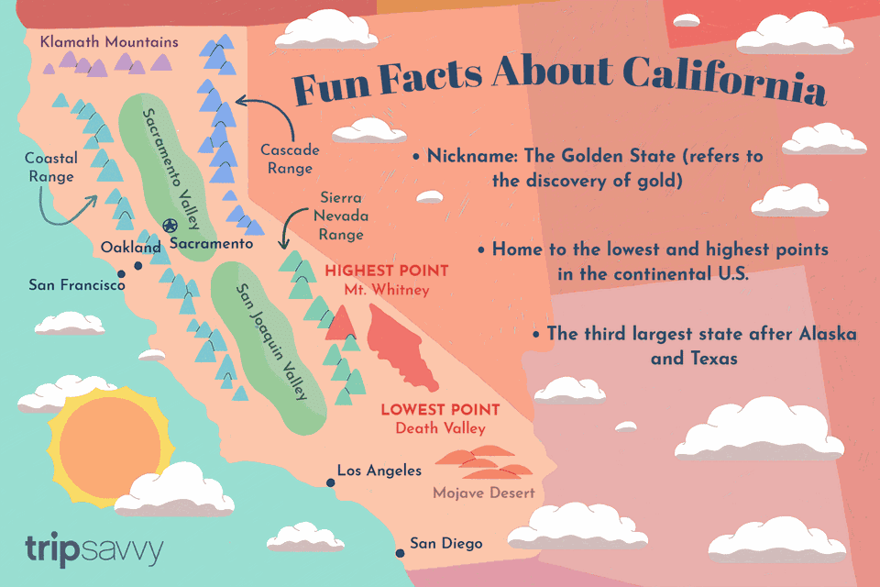
AXE 2: Les univers professionnels, le monde du travail

CALIFORNIA DREAM JOBS
Key question: Why is California so attractive to young workers?
DOC A:
a. Look at the photograph and say what jobs are linked to Hollywood. Make a list.
b. Listen to the recording and present Andrew’s job in details.
- Say what he learnt.
d.Say what he enjoyed.
Working on a film set (= plateau de tournage) in Hollywood

DOC B:

- Read the ad and say what job it advertises.
- Where is it located exactly?
- Explain what it consists in.
- What qualities and skills are required?

DOC C:
- Explain what a Millennial is.
- Do research on Silicon Valley. What and where?
- Read the article and say what kinds of jobs you will find in Silicon Valley.
- Find three reasons why it appeals so much to young workers.

DISCUSS: If you had the opportunity to intern in California for a few months, which job would you like to apply for? Why? Use the Words section to express your desire.

