AXE 8 TERRITORY & MEMORY SET IN STONE

Task 5 : Listening (SS, NPR, 2018)
1. Nickname of the statue:
2. It is the statue of a Union soldier Right Wrong
3. It was erected ___________________________ years ago at the University of South / North Carolina in Chapel Hill.
4. How many protesters toppled the monument ?
5. Why did they take down the statue ?
Protesters viewed it as a symbol of racism
Protesters saw it as a symbol of black supremacy
Students had been given the right to do so
Protestors saw it as a symbol of white supremacy
Protesters wanted to support the person who had vandalized the statue earlier that year
6. It was not the first time the statue had been vandalized RIGHT WRONG
7. Maya Little is a ________________________ student who tossed blood and ________________ paint over the statue to put it in proper context.
8. What other reason does she put forward?

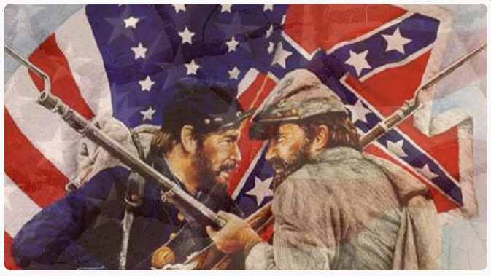
Task 6: BOOST your SKILLS

The Secession – Historical context
Complete the blanks with a verb in the past tense.
A common explanation is that the Civil War was fought over the moral issue of slavery but in fact, that war (be) _ _ _ _ _ _ _ _ _ _ the climax of escalating tensions between the north-based Union and the south-based Confederacy. Indeed, between1840 and 1860, Southerners frequently (threaten) _ _ _ _ _ _ _ _ _ _ to withdraw from the Union. The North (desire) _ _ _ _ _ _ _ _ _ _ the industrialization of America, whereas the South was rooted firmly in their agriculture-based lifestyle that (depend)_ _ _ _ _ _ _ _ _ _ on the labour of Black enslaved people to grow certain crops, especially cotton and tobacco. The protective Tariff of 1828, - called the Tariff of Abominations by Southern states, (mark)_ _ _ _ _ _ _ _ _ _a turning point since imported goods were heavily taxed. As the South was not a manufacturing centre, it (have)_ _ _ _ _ _ _ _ _ _ to import finished goods from the North and (end) _ _ _ _ _ _ _ _ _ _up paying up to 80% of federal tax. Many southerners (be)_ _ _ _ _ _ _ _ _ _ convinced that law had been enforced to protect the rapidly growing industry-based economy of the North at the expense of the southern economy. In addition, they (think)_ _ _ _ _ _ _ _ _ that their economic survival was at stake because of growing abolitionist sentiment in the North and opposition to the extension of slavery into the new western territories.
As a result, eleven states (vote)_ _ _ _ _ _ _ _ _ _ to secede on February 1, 1861, - a political decision which (result) _ _ _ _ _ _ _ _ _ _ directly in war. The Northerners’ goal was to free slaves but also to preserve and save the Union. The Emancipation Proclamation in 1863 (deprive)_ _ _ _ _ _ _ _ _ _ the South of most of its labour forces but it also (win)_ _ _ _ _ _ _ _ _ _ over international public opinion.
This war (last)_ _ _ _ _ _ _ _ _ _ from 1861-1865 and (divide)_ _ _ _ _ _ _ _ _ _ the nation into the “north” and the “south”. Even if today, most academic scholars identify slavery as the central cause of the Secession War, its causes are far more complex and have been controversial since its very beginning.

