AXE 1: Identités et échanges BY JOVE
(Ça alors !)
KEY QUESTION: Who do the English think they are?

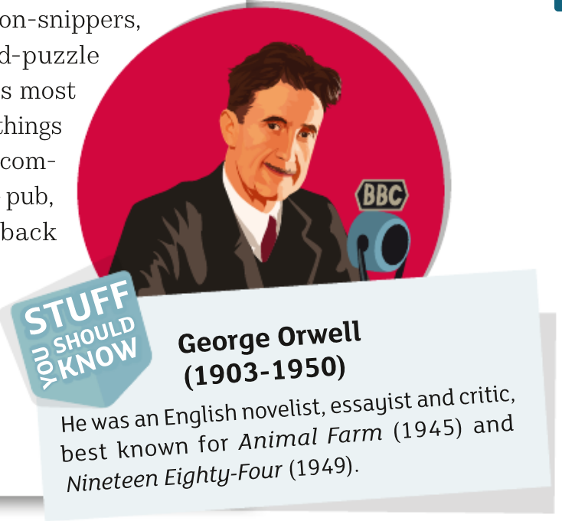
FEED 1: The Quest for National Identity
What does it mean to be English?
Read the text from George Orwell, then answer the questions.

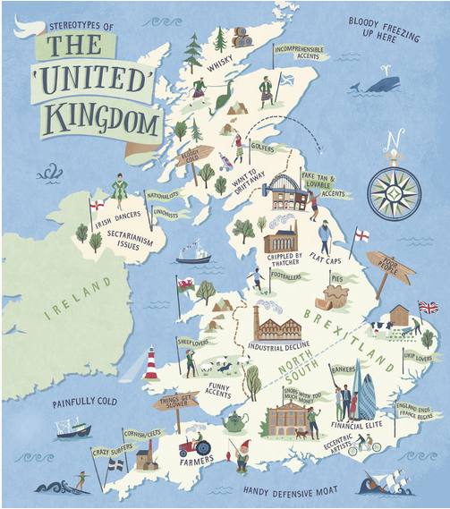
- Read the title of the essay. Who is the writer speaking to?
- How do English people feel when they return home from abroad? (read from l.1 to 13). What strikes them first?
- Read the second paragraph. Some English stereotypes are listed. List them and say what these stereotypes refer to?
- Why is it “of the deepest importance to try and determine what England is” (l.27-30)? Complete the missing information.
Orwell thinks it is necessary to try and define what England is in order to /dɪˈtɜː^{r}mɪn/ _________________ England’s role in the world, and more precisely what role England can play in the fight against /ˈnɑːtsɪzəm/ ______________. The essay was written in 1941 in the context of a /dɪˈvaɪdɪd/________________ Europe, /ˈdɛvəsteɪtɪd/ ___________________ by war. Orwell seems to be trying to /ˈgælvənaɪz/ __________________a /ˈgælvənaɪz/__________________ spirit.

- Pick out what sets the English apart from their neighbours. (l.31 to l.59)

- Conclusion. Translate the following sentences in English
L'Angleterre est donc à la fois diversifiée et unifiée.

Les anglais sont clairement différents de leurs voisins européens à bien des égards.

Pourtant, ils ont de nombreux passe-temps et profitent de leur temps libre.

La culture populaire est une partie importante de leur identité.

Ces différences, aussi insignifiantes soient-elles, nous aident à comprendre qui sont les Anglais.

