AXE 1: IDENTITY & EXCHANGES FOOD FOR THOUGHT

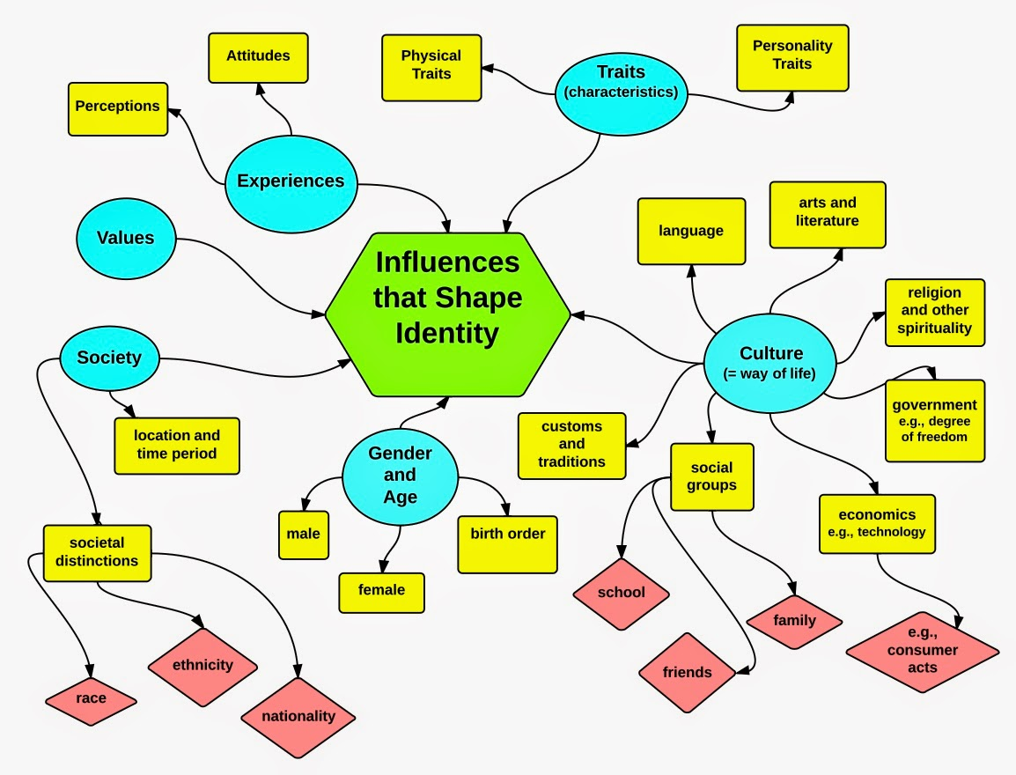
IDENTITY? It is basically WHO YOU ARE (what you think about you, how people see you, the characteristics that define you).

It is mostly IMPOSED ON YOU BY VALUES, BY OUR SOCIETY.

Identity is who you are, the way you think about yourself, the way you are viewed by the world and the characteristics that define you. An identity can be given by your name and can be related to your values that dictate the choices you make. Most of the time, you do not choose your identity; instead, you simply internalize the values of your parents or the dominant culture.

Identity may be acquired indirectly from parents, peers and other role models. The way they see you may determine how you see yourself. Identity may also derive from the rules of society in which you live and which impose membership rules and expected behaviours. An identity can also be an individual reflection of how you want to be seen at any one time by choice: it may be socially distinguishing features that you take a special pride in and that you want people to identify you with.

However, your identity can also evolve with time, experience, work, life accidents, challenges, hobbies, trips and encounters. The others can change your way of seeing the world, thinking and acting, and can be changed in return. Whether it is marriage, work relationships, friendships, support networks or exchange networks, these personal interrelationships can result in similar traits.

Identity can also be larger than an individual and encompass a nation. National identity is a person's identity or sense of belonging to one state or to one nation, represented by distinctive traditions, history, culture, language, symbols and politics. Yet, national identities are sometimes challenged by external phenomena. As immigration increases, some countries face the challenge of constructing national identity and dealing with immigrants; some adopt an inclusive policy encouraging immigrants to build a sense of belonging, while others have a more exclusive policy, excluding immigrants from sharing the national identity.

Un sentiment d’appartenance |  | Assimiler, acquérir
inclure |  | évoluer
Des caractéristiques |  | Des rencontres
Une politique, une pratique |  | Des pairs
Une valeur |  | S’identifier à
EXCHANGES? An exchange is the act of giving something to someone in return for something from another. It can be material or immaterial (knowledge, culture, …). Exchanges are often used to characterize mobility, as well.

Gap years are good examples of personally transformative experiences. During this time taken off between high school and university, a gapper can travel abroad and carry out international internships or volunteer in local communities. The experience helps participants discover who they are and identify their true passions. They become strong, proactive and civically engaged community members.

CONCLUSION:

Therefore, identity results from a broad range of influences, both internal and external.
It is unique and multifaceted, but also both steady and evolutionary.

The world also becomes increasingly globalised, with more developed international tourism, communication and business collaboration. People around the world cross national borders more frequently to seek cultural exchange, education, business and different lifestyles.

Globalisation promotes common values and experiences, and it also encourages the identification with the global community. Yet, this trend may threaten national identity because globalisation undermines the importance of being a citizen of a particular country and may lead to a form of acculturation.

What does a gap year consist in?

To threaten |  | steady
A lifestyle |  | evolutionary
knowledge |  | A citizen
A gap year |  | A border
acculturation |  | To seek
A trend |  | To undermine
globalisation |  | proactive
multifaceted

