MISSION 2: Famous artworks and controversy

- Focus on Banksy’s works of art. What strikes you about them?
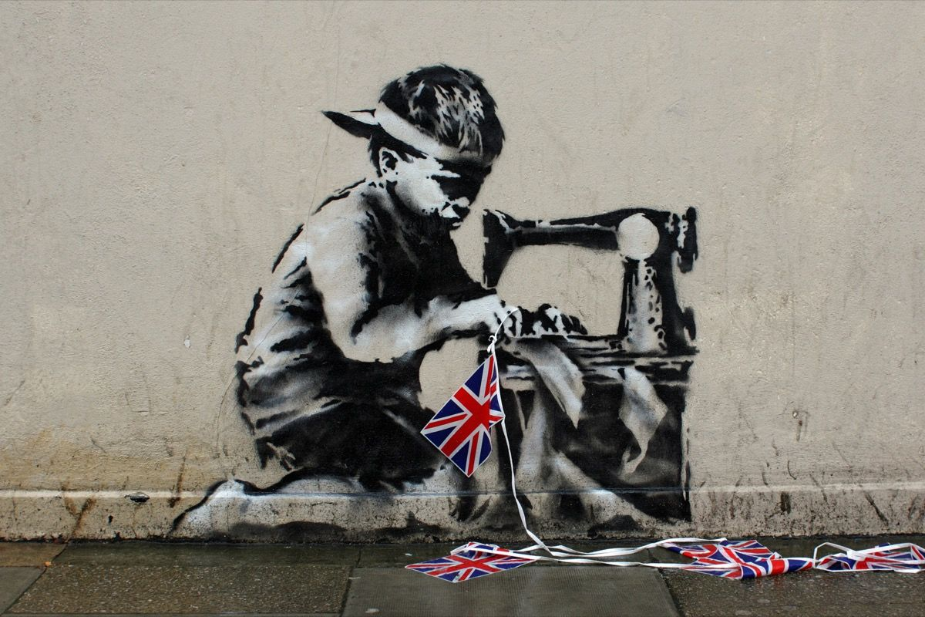
- Describe each artwork.
- Explain what messages they convey?
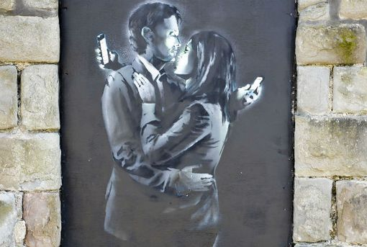

Slave Labour, 2012

Mobile Lovers, 2014

a. Both artworks are quite ironic and seem ________________(déclencher un débat). In both works, ________________ (= insaisissable) Banksy ________________ (apporter un éclairage sur) society’s ________________ (défauts). Banksy is cynical / ironical / controversial/ provocative about our society.
- Mobile lovers:
This artwork by Banksy ________________ (= s’intitule) Mobile Lovers and ________________ (a été dessiné) in 2014. It shows two people, one man ________________ (à gauche) and most probably his wife or lover ________________ (à droite) WHO are ________________ (= s’enlacer). Both look very elegant in their suits however, ________________ (= au lieu de s’embrasser), both are holding and ________________ (= fixent) their own mobile phone, as we can see the light from their phones reflecting onto their faces.
Slave Labour. Slave Labour is a mural that was painted by Banksy, in London in May 2012. It ________________ (= illustre, représenter) an ________________ (= gamin des rues), ________________ (en haillons) who has a cap on and looks rather ________________ (= triste). He ________________ (= est agenouillé) and using ________________ ( = une machine à coudre) to assemble a ________________ ( = guirlande de fanions) of Union Jack flags.
c. In Mobile Lovers, Banksy ________________ (= dénonce) people’s ________________ (= dépendance) to their cellphones. ________________ (= malgré) the intimate situation, they prefer looking at their phones ________________ (= plutôt que) at each other.
In Slave Labour, Banksy probably wants ________________ (= sensibiliser) ________________ (= le travail des enfants) in ________________ (= pays en développement). This work was a protest against the illegal use of kids who worked in ________________ (= ateliers de misère) to manufacture London Olympics ________________ (= souvenirs) in 2012.

