Pro-AI or Pro-Humans
KEY QUESTION: Do we have to fear AI?

MISSION 1: Do you know these men? Who are they? What do they have in common?

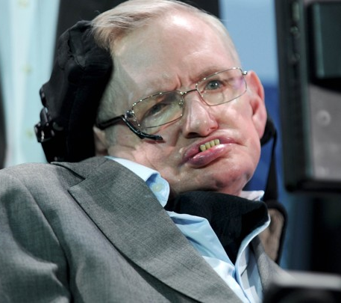
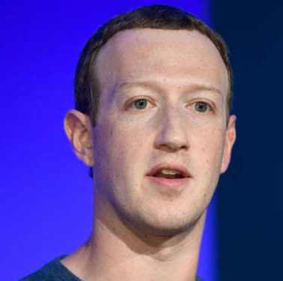
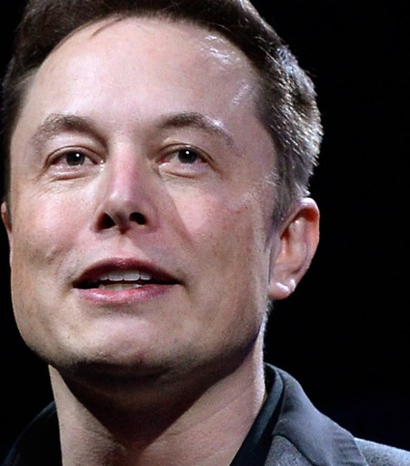
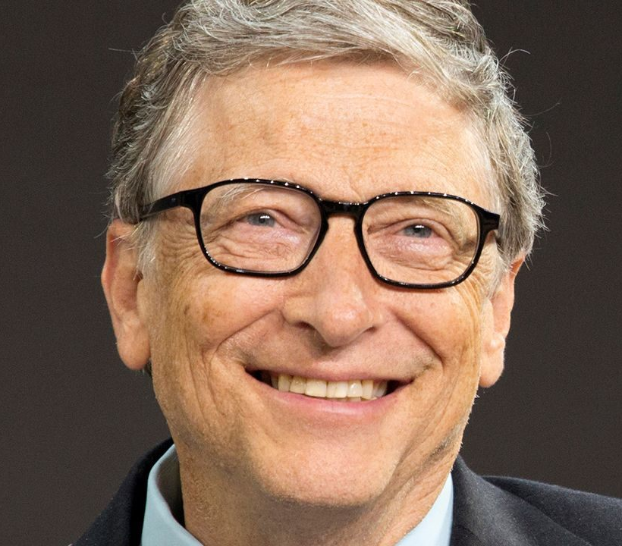

_____________ ______________ _______________ ___________________
(1955- ….) (1971 - …) (1984 - …) (1942 -2018)
Famous English ______________ and ___________.

CEO of ____________
(chief executive officer)
Main founder of __________. Today he is a _____________ and he runs the largest charitable organization in the world.
Inventor of __________ (electric cars), Paypal, ______________ (starship which will reach Mars)+ hyperloop.

MISSION 2: Read these quotes and compare and contrast them. Are they optimistic about AI or not?

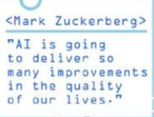
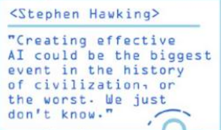
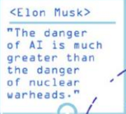
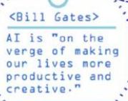

MISSION 3: Understanding the debate
Read the article Mark Zuckerberg doubles down defending A.I after Elon Musk says his understanding of it is ‘limited’

- Introduce the document (type, source, date, author, topic)
- Why are Mark Zuckerberg and Elon Musk referred to as ‘two of the biggest tech titans’?
- Read the article and pick up equivalent expressions.

- A piece of beef meat (l.21 – l.24) =
- A large group of things (l.21 – l.24) =
- To have an impact on (l.25 – l.29) =
- The most advanced (l.30 – l.35) =
- When you disapprove if something sharply (l.36 – l.41) =
- Someone who is negative about everything (l.31 – l.41) =
- The end of the world (l.36 – l.41)=
- A criticism, a reproach (l.42 – l.45) =

- Here are some adjectives. Say who they refer to.
a. optimistic and confident:
b. pessimistic and fearful:

- Say if the following statements are right or wrong and justify your answer by quoting from the text.

- Mark Zuckerberg admits openly that he doesn’t know anything about A. I.

- He is convinced that the potential of A. I. is broadening our horizons in many different fields.

- Elon Musk sees eye to eye with Mark Zuckerberg about this potential.

- Elon Musk is convinced that A. I. will one day cause the downfall of humankind.

- According to him, Mark Zuckerberg is not the most qualified person to debate about AI.

- Answer the following questions in complete sentences.

- Why is Mark Zuckerberg so optimistic about the potential of artificial intelligence?

- What accounts for Elon Musk’s pessimism?

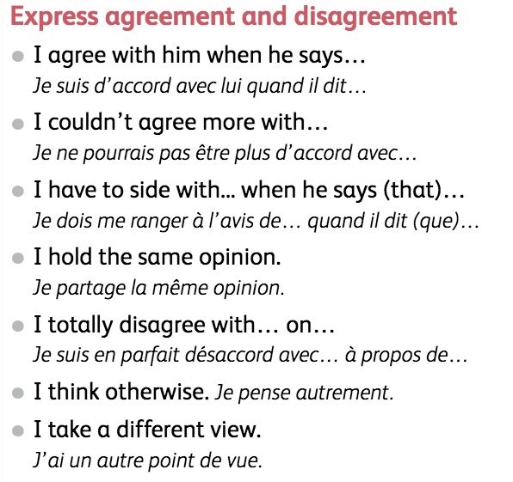
- Now give your opinion. Who do you agree with?

d. Do you have to be an expert to express your views on a burning issue?

