AXE 6: SCIENTIFIC INNOVATIONS & RESPONSIBILITY A.I : FRIEND OR FOE?

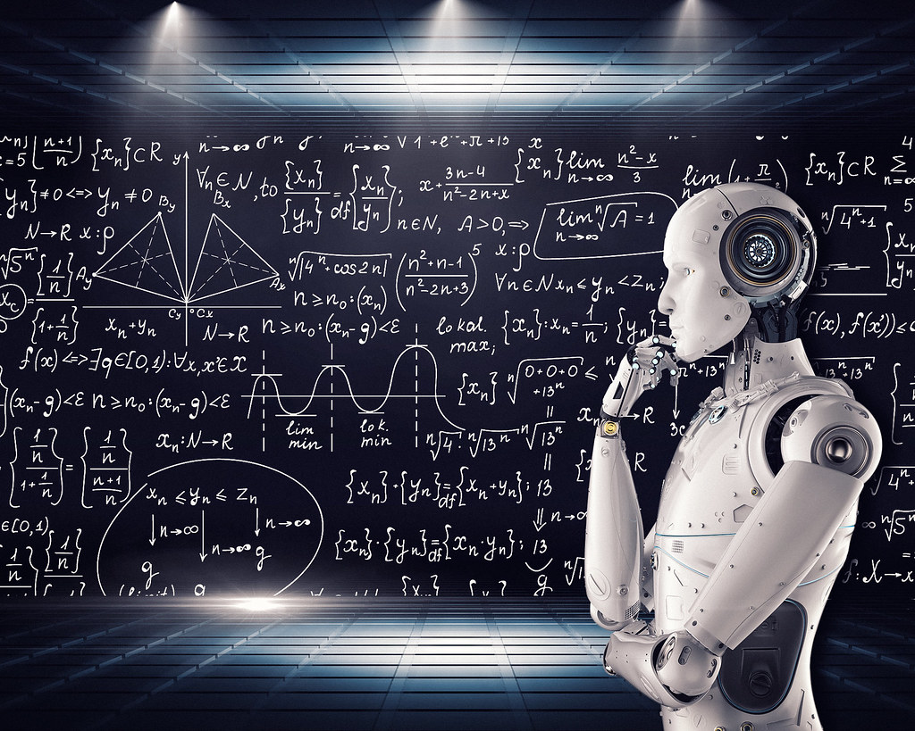
KEY QUESTION: To what extent can Artificial Intelligence change the way we live?

MISSION 1: WARM-UP
- Are you interested in robotics?
- What is AI /eiai/?
- Can you list examples of AI we use in everyday life?
- What do you think is the most important technological advancement ever made?
- What other technological advancements/inventions would you like to see in the future?

MISSION 2: Listen and complete the following video by The Royal Society Organization
Source Link: https://www.youtube.com/watch?v=nASDYRkbQIY

These are _______________________ times for Artificial Intelligence or AI. But what is AI?
AI is the science of making machines _______________________ using algorithms to allow computers to ________________ problems which used to be solved only by humans. AI already ____________________ search engines, online shopping recommendations, and digital assistants.
_______________________ can use AI to calculate the exact shape and volume of ___________________, revolutionizing treatment.
_______________________ use AI to find and evaluate exoplanets in distant solar systems.
And unhappy motorists are using it to discover if they can overturn parking _______________________.

The possibilities of AI are _______________________, from fraud prevention to developing new strategies to address climate change. AI technologies today are _______________________ at analyzing vast amounts of data to learn to complete a particular task, a technique called Machine Learning.
But AI is ____________________________transferring what it’s learned from one type of task to another; learning abstract concepts; and ‘one-shot’ learning where a general rule is learned from a single experience -the sort of broad intelligence humans _______________________.

But even without achieving this _______________ intelligence, AI ________________________________. How might AI affect work? People will still be needed in the workplace, but jobs and roles ____________________________ change as some tasks become automated and new jobs are created. There is a risk that, at least in the short term, this could ___________________________________, if some people are disproportionately affected and benefits aren’t widely shared across society. And what about social ___________________________________________? Bias coming from AI systems, even if unintentional, could disproportionately affect some social groups, influencing anything from job prospects to treatment by the justice system.
Technology can play a role in helping to manage _______________________; but people need to address big questions about how society wants to use AI.
Technology with AI at its heart has the power ____________________________________________________. The more of us that engage in shaping its development, the more chance we have to ensure a ___________________,_______________________ future with AI.

MISSION 3: Vocabulary
Match the words in A to their definitions in B.
ANSWERS:

1.
2.
3.
4.
5.
6.
7.
8.
9.
10.

Column A Column B

- Algorithms a. Big/immense
- Revolutionize b. computerized/machine operated
- Overturn c. Sets of rules, calculations, etc.
- Vast d. to secure/ make certain
- Abstract e. not equally given/done
- Ensure f. prejudice/ unequal treatment
- Automated g. options/opportunities
- Disproportionately h. to reverse/ to turn
- Bias i. opposite of very specific/particular
10.Prospects j. to change in a radical/big way

MISSION 4: Find the English equivalents in the document we have just studied.

ENGLISH | FRENCH | ENGLISH | FRENCH
 | soulever un problème |  | une contravention
 | traiter un problème |  | immense
 | résoudre un problème |  | automatisé
 | permettre |  | plus juste, plus équitable
 | garantir |  | impartialité, équité
 | annuler |  | parti pris, préférence
 | alimenter |  | perspectives d’emploi
 | exceller dans
 | être probable que

MISSION 5 : Complete this article using might, will or be going to, either in the affirmative or negative form.
Could AI replace teachers ?
Let’s imagine a full humanoid robotic AI educator at the front of the room. Surely, this AI is less likely to make content area errors. It _________________ be able to access absurd amounts of information in the blink of an eye. It would be able to listen and answer questions. It _________________ soon even have the ability to read the faces of students and respond accordingly.
What it _________________be able to do however is combine these elements along with a thousand other human variables to create meaning. So teachers’ jobs are safe for the near future.
But based on what is already happening in other countries some things _________________ change, and AI _________________ play a part. And although robots _________________ be sitting in the teachers’ chairs, they _________________ be joining teachers quite soon as teaching assistants.

