AXE 6: Innovations scientifiques et responsabilité A.I : FRIEND OR FOE ?
KEY QUESTION: To what extent can Artificial Intelligence change the way we live?

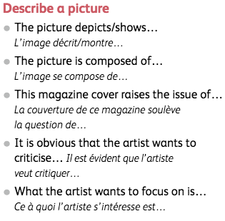

MISSION 1: What will the next generation be?
Look at the above document and react.

- Introduce the document
- Focus on the scene and describe it. Explain how the man is represented.
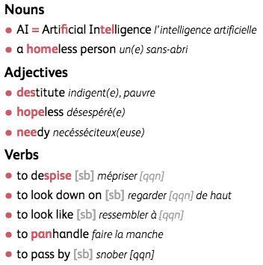
Make suppositions about his situation

- What do these pictures tell us about Artificial Intelligence and animals in the future?
- Draw a conclusion about the artist’s message.

YOUR OPINION: Do you agree with the artist’s view on A.I?

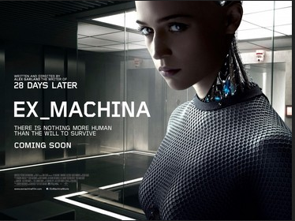
MISSION 2: Listening Comprehension

Go on the blog and listen to the mp3 recording entitled “Ava, from Ex-Machina”.

List as many characteristics as you can, concerning Ava…
What do you learn about her?

Be ready to summarize what you have understood in class.

