AXE 6: SCIENTIFIC INNOVATIONS & RESPONSIBILITY A.I : FRIEND OR FOE ?

AI-POWERED TECHNOLOGIES

VIDEO Next generation robots
Watch the video and recap what you have learnt about the 2 technological breakthroughs presented.

Name, date:
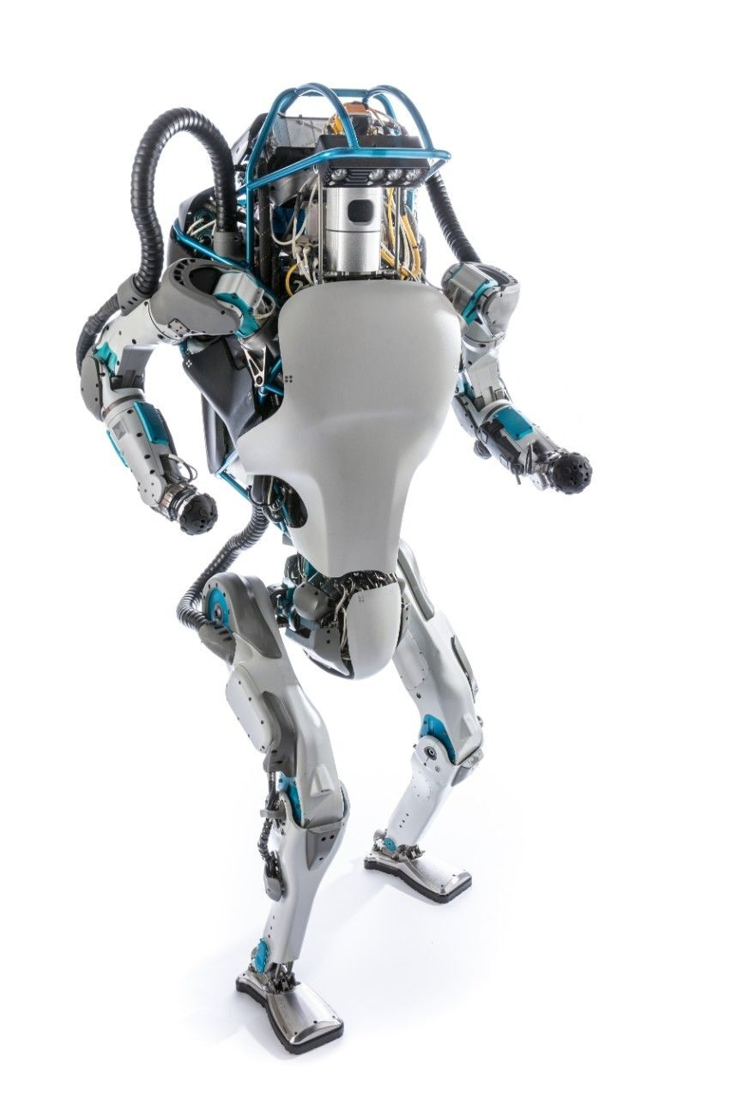
Advantages:
-

-

-

-

Robot n°1
Purpose:

Risks:
Characteristics:
-

-

Name:

Advantages:
-

-

Robot n°2

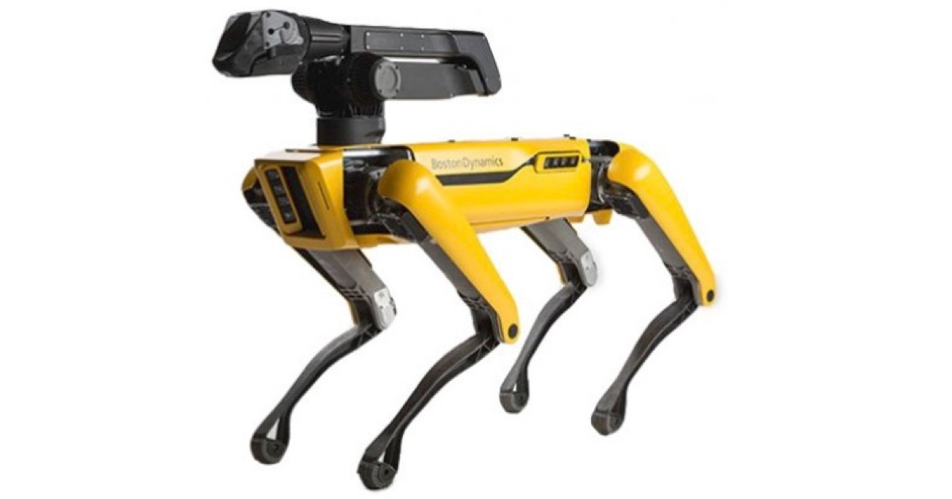
Characteristics:
-
-
-
-
-

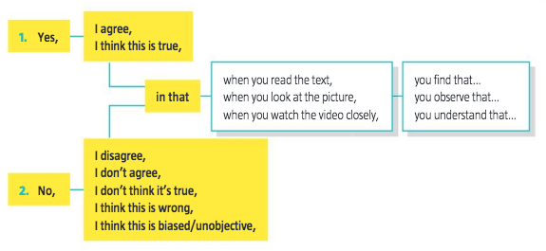
React : The narrator in this documentary says of the last robot : « Many people did find it a bit creepy but I really just see good engineering. »
Do you agree with this statement ? Why ? Why not ?

