MORE AI-POWERED TECHNOLOGIES

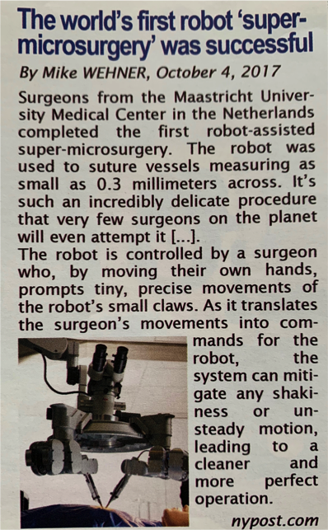
AI in the medical field
Document 1: Read and make an account of what you have understood. Finish or complete the sentences.

The document under study is ……………………………... on October 2017 on the NYpost website.
It …………………………… “The world’s first robot ‘super-surgery’ was successful” and it …………………………… Mike Wehner.
It deals with…………………………………………………… which …………………………………………for the first time in the Netherlands.

This robot allowed the surgeon who was manipulating it to ……………………………………………………............ .

This robot proved to be ………………………………… the surgeon’s hands.

……………………… human hands, this robot is …………………… and does not ………………….. so the result was …………………………………………………….. .

Deep sea exploration

Document 2: Watch and complete the missing information in French.

Nom:

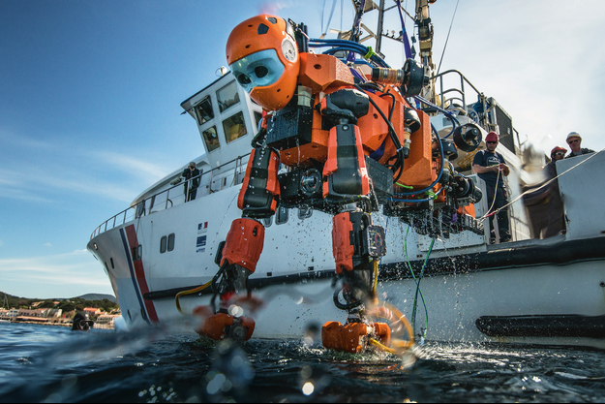
Caractéristiques:
1.

2.

Utilisation:
1.

2.
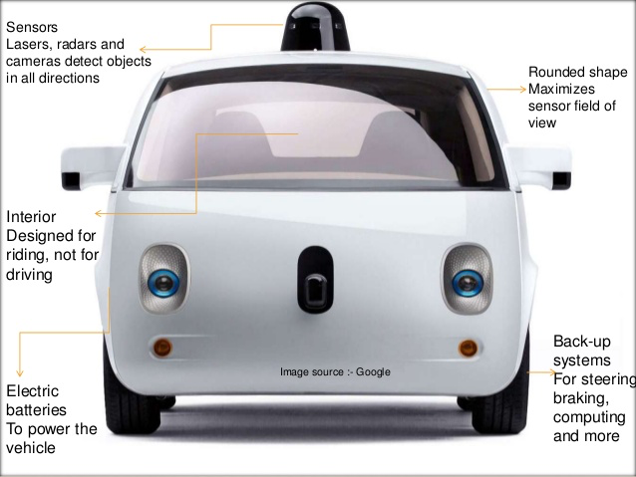
Mode de fonctionnement:

Driverless cars

Document 3: Watch the document
Driverless cars and make an account of
what you have understood in French.

