AXE 2 : Espace privé et espace public / Private and public sphere

INTRODUCTION
Be logical and complete the following introduction with the given vocabulary

have evolved / male-dominated / were restricted / though / has been difficult for / have had to fight

For centuries, women ______________________ to the domestic (private) sphere.
And ______________________ our western societies ______________________, it ______________________women to enter the public sphere.
They ______________________ to gain recognition and more rights in a ______________________ society.

Chapter 3 : Women of Prohibition
Key question : How did American women’s place in society change with Prohibition?

Mission 1: Cultural Background
Read the Cultural file on Prohibition on the blog and try to complete the missing elements.

Prohibition in the USA lasted for ________________ from ________________ to 1933.
During this paradoxical period, ________________ couldn’t be ________________, ________________ or ________________ which means it was ________________ but the fact of ________________ alcohol was not mentioned in the ban.
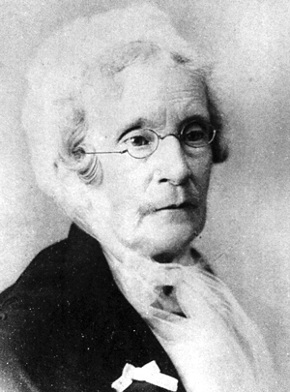
Eliza Thompson (1816-1905)

an advocate = a defender, a militant
To advocate = to promote, to encourage

As a member of the WCTU ( __________________________________), Eliza Thompson’s aim was to ______________________________alcohol. She _________ a crusade ____________ alcohol in saloons where she __________________ and __________________________ of the establishments with other female advocates.

Changes in The Roaring 20s (The Jazz Age) are synonymous with _ _ _ _ _ _ _ _ _ _.
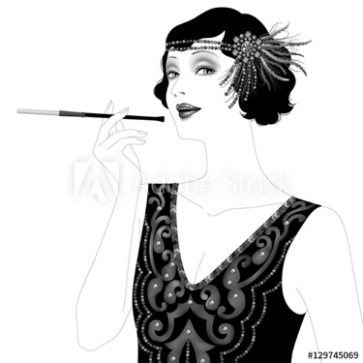
the upsurge= the increase
a flapper = une garçonne
a speakeasy = un bar clandestin
to usher in = announcer, entrer dans

- Growth of ……………………………………..
- Rise of ………………………………………...
- Increase of …………………………………….
- Revolution in ……………….: sexual codes, gender roles
- Revolution in manners: Women’s …………………… and dresses …………………...

The word “flappers” was introduced and corresponded to ………………………….. with a short “bob” hairstyle, a cigarette ………………………. their painted lips, drinking in …………………….. and …………………… to a live jazz band.

IMPORTANT landmarks ( = ……………………………….) to remember:

19 _ _ : Ratification of the _ _th Amendment to the Constitution which …………………the production, sale, transportation, importation or exportation of alcohol.
19 _ _ : Ratification of the _ _th Amendment to the Constitution which ……………………………….to vote for women in the USA. (thanks to the NAWSA, the National American Woman Suffrage Association)

Give a definition of a Speakeasy:

a den = un repaire (illegal place)
patrons = customers from a bar in the 20s

Customers had to whisper (to speak “easy) when entering the hidden bar, not to be noticed (repérés).

CONCLUSION: Complete with the appropriate tense

During the 20’s, women (ont renversé) ………………….. social conventions and (sont descendues) ………………………………. the streets to fight against the suppression of alcohol, ( pour s’élever contre l’inégalité des exes) ………………………………………………and thus, gained liberation. The women of Prohibition (ont changé l’Amérique pour toujours) ………………………………………… .

HELP SECTION: To upturn = renverser
To take to the streets = descender dans la rue
To speak out against = dénoncer
Gender inequality = l’inégalité des sexes

