AXE 3: Art et Pouvoir ARTISTIC VIEWS

KEY QUESTION: Does art reflect the world we live in?
Time for debate:
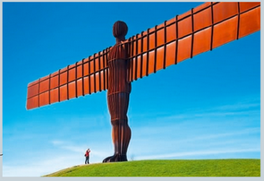
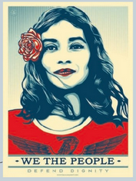
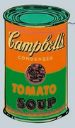
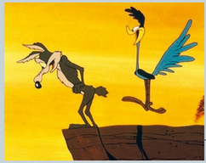

- Campbell’s Soup Can (Andy Warhol, 1962)
- Defend Dignity (Sheperd Fairey, 2017)
- Angel of the North (Antony Gormley, 1998)
- Road Runner and Wile E.Coyote (Chuck Jones, 1949)
MISSION 1: What do the four works above have in common? What do they show?
MISSION 2: What is art for you? Can a can of tomato soup be considered as art? Can a cartoon from 1949 be considered as art?

