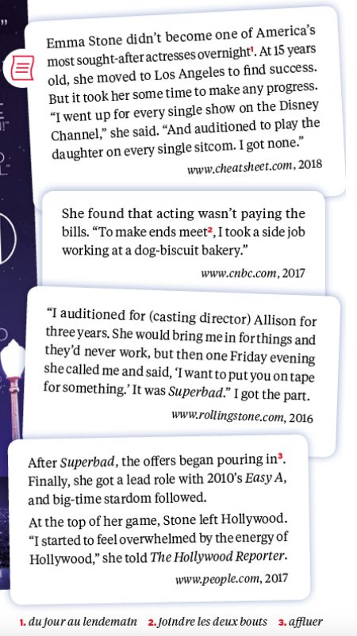
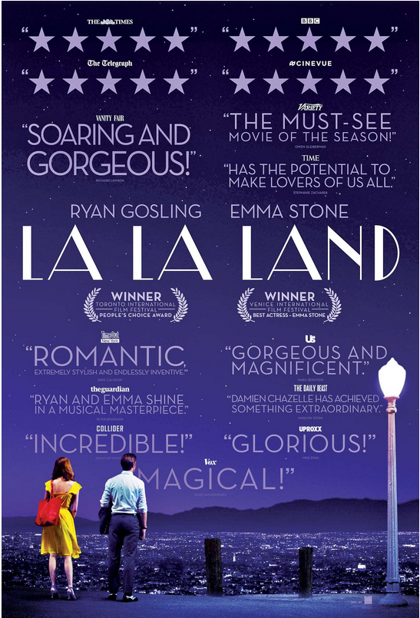
PART 2: The Ultimate Dreamland

Docs 1 and 2:
- Look at the film poster and read the texts. Pick out information about Emma Stone (jobs, film, award).

- Focus on “She would bring me in for things”. What does “would” express?
- Listen to Emma Stone’s interview. Pick out information about her story.
- Explain how these documents give a contrasting view of “becoming an actress in Hollywood”. Use the WORDS section to answer this question.
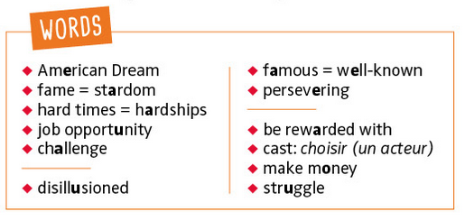

Docs 3 and 4:
- Watch the video, read the testimonies and explain how the natural environment makes Silicon Valley an ideal workplace.
- Comment on the international dimension of the work done there.
- Read the comments and explain why living in the Silicon Valley is a “double-edged sword”.
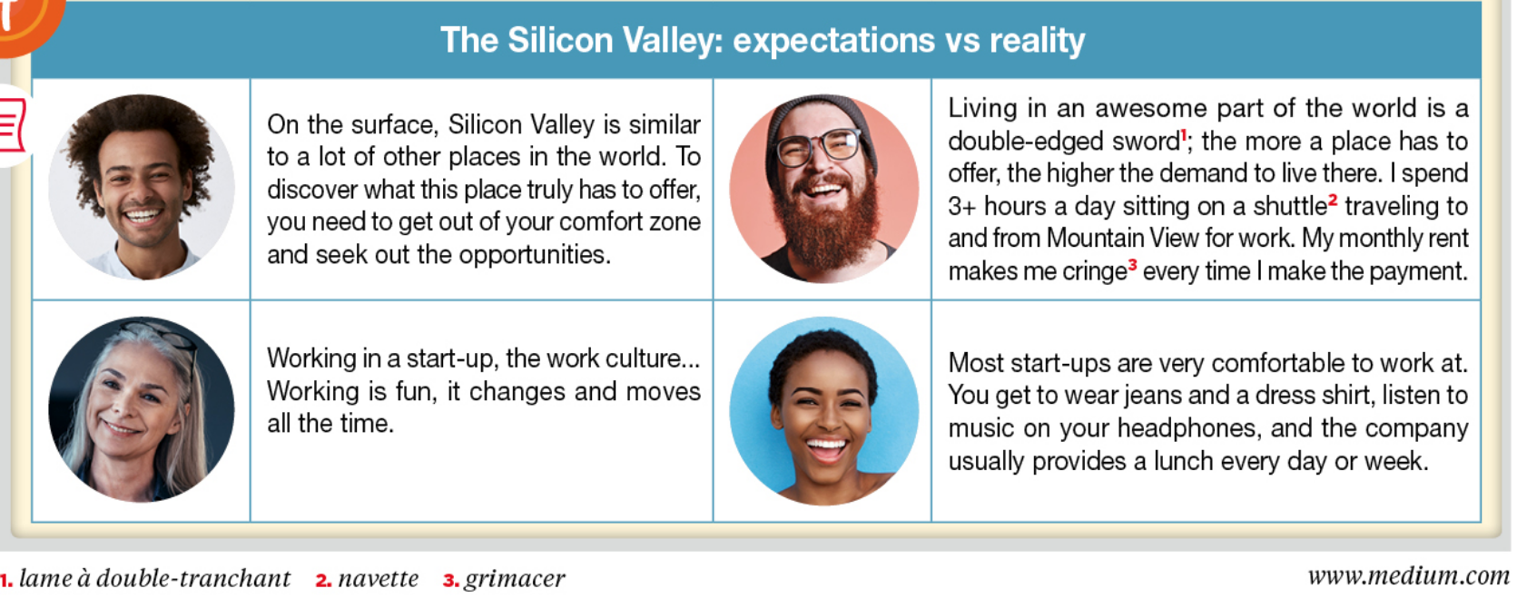
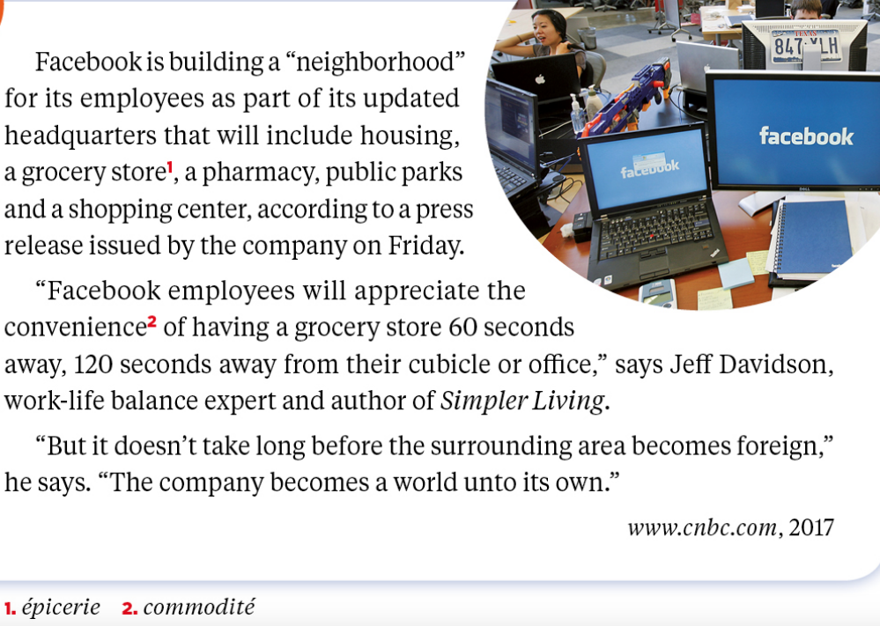
Final step: The new Facebook headquarters

- Read and find information about the new Facebook headquarters.
- Pick out elements to discuss the pros and the cons of this new place.
- Explain this expression: “the surrounding area becomes foreign”.

