TASK 4: Shopping 10 pts

1. ____________________ is a trendy and fashionable neighbourhood in London with a distinctive, small-village feel, made famous by a movie of the same name.
2. ____________________ is famous for its street entertainers and lively atmosphere.
3. Located at the heart of London's West End, ____________________is one of the world's most prestigious and lifestyle destinations, famous for its flagship stores and international brands.
4. ____________________is one of the longest shopping streets in London (2 Kms).
5. ____________________is the very symbol of high class shopping in London.
6. ____________________is the oldest and largest toy shop in the world.
7. ____________________welcomes the world's largest antiques market, with over 1500 dealers selling every kind of antiques and collectables.

8. ____________________ markets in Northern London are popular on the weekends selling variety of alternative fashion, lifestyle, ethnic food and bizarre goods.
9. ____________________was once considered the "Capital of Cool," it was also the epicentre of the British youth revolution during the 1960s. Its influences on London's fashion, shops and touristy industry can still be seen today.
10. Over the past decade, ____________________has grown into a shopping destination. Big brands, designer boutiques, indie labels and quirky thrift shops are muddled together.

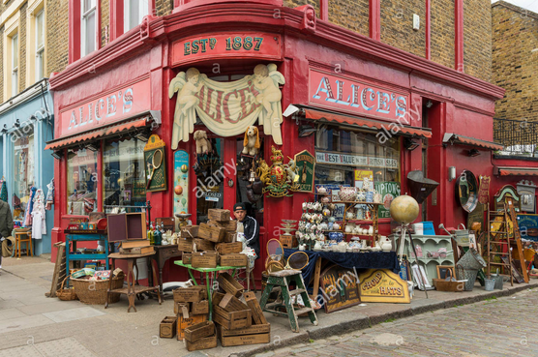
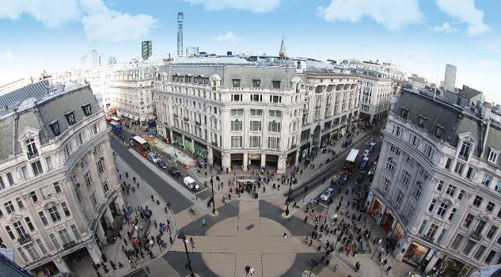
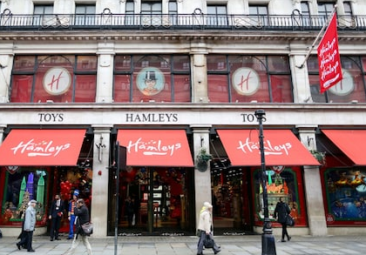
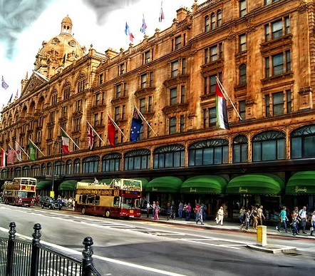
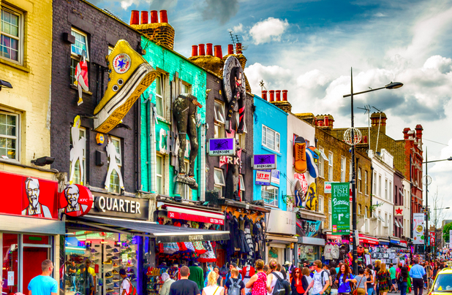
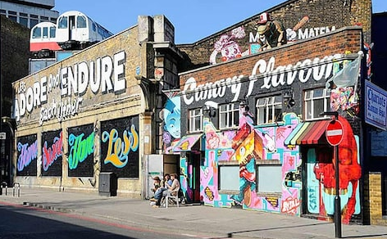
Camden Town / Shoredich / Covent Garden / Carnaby Street / Hamleys /
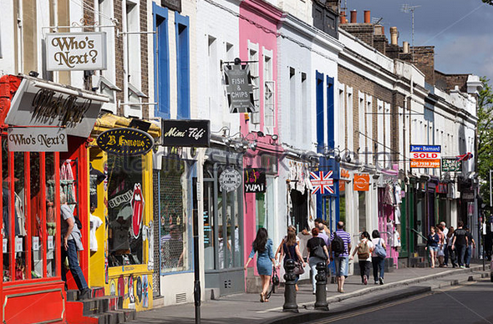
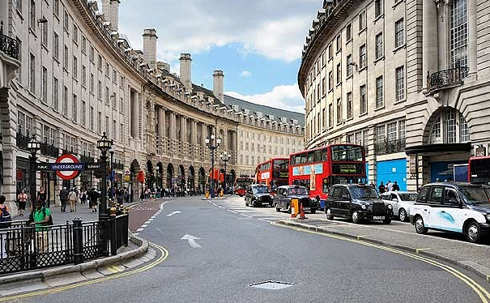
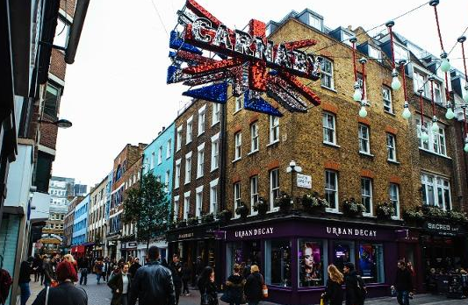
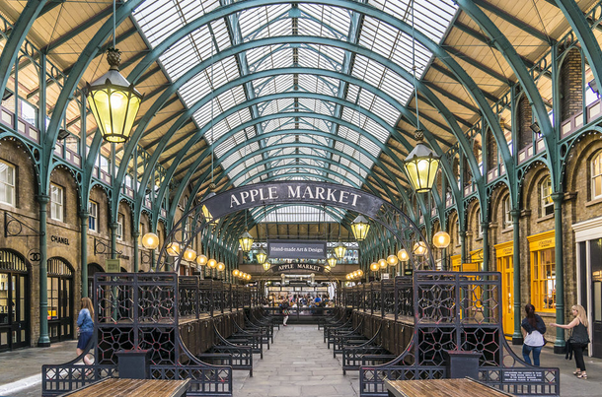
Harrods / Regent Street / Notting Hill / Oxford Street / Portobello Road

