**TASK 2: Famous places in London – Which is which?**

## A1. London’s Most Famous ☺ 10 pts

1. ______________________ commemorates the Great Fire of London of 1666.

2. _____________________ houses the Prime Minister's private apartment, the Cabinet Room, the State Dining Room, where official guests are entertained, and government offices.

3. _____________is actually the name of the biggest bell within The Clock Tower of the Houses of Parliament.

4. ___________________is Sir Christopher Wren's masterpiece, built between 1675 and 1708 to replace the previous cathedral destroyed in the Great Fire of London in 1666.

5. ___________________is the most famous church in Great Britain. The kings and queens of England are crowned there, and many rulers and famous men of Britain are buried there.

6. ________________________is the official home of the Queen.

7. _________________________takes place in the forecourt of Buckingham Palace at 11.30 every day in summer, every other day in winter, and lasts about 45 minutes.

8. ____________________________, otherwise known as The Palace of Westminster, is the siege of Parliament, the legislative assembly of Great Britain.

9. ____________________________, the main hub of Central London, was built in honor of Admiral Nelson after his victory in 1805 at the Battle of Trafalgar, off the coast of Spain.

10. Throughout its long history, ___________________________has served as a royal palace and fortress, prison and place of execution, an arsenal, royal mint, menagerie and jewel house.

**A2. Write the names of the places or events under the corresponding pictures (see exercise A1) ☺ 10 pts**

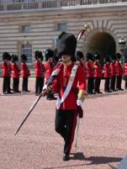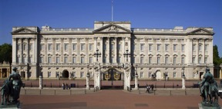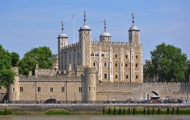

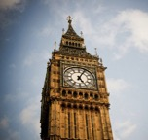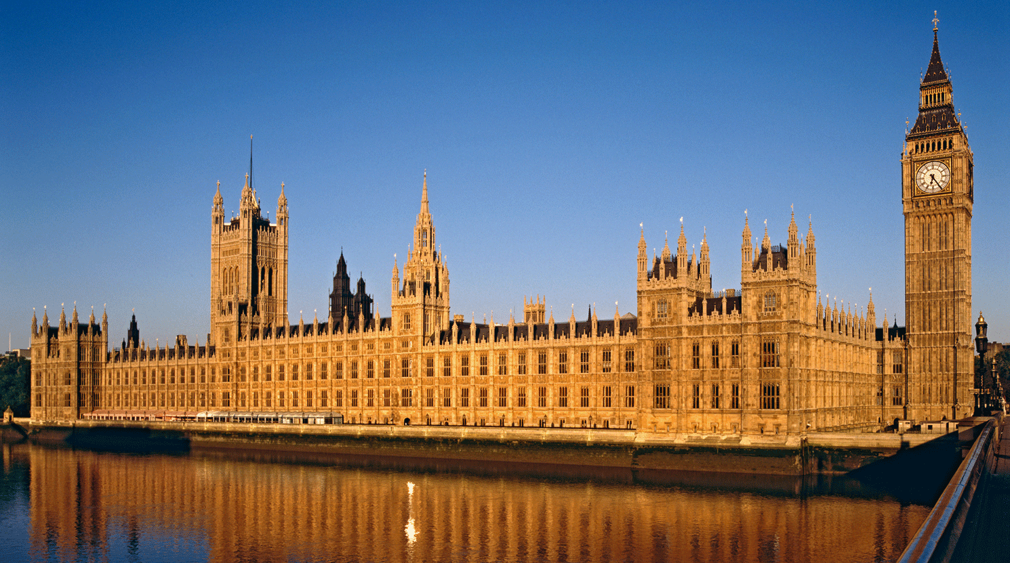

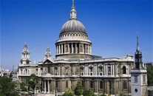

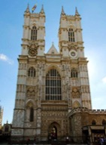

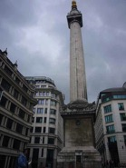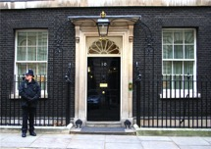

## fficher l'image d'origine

## 