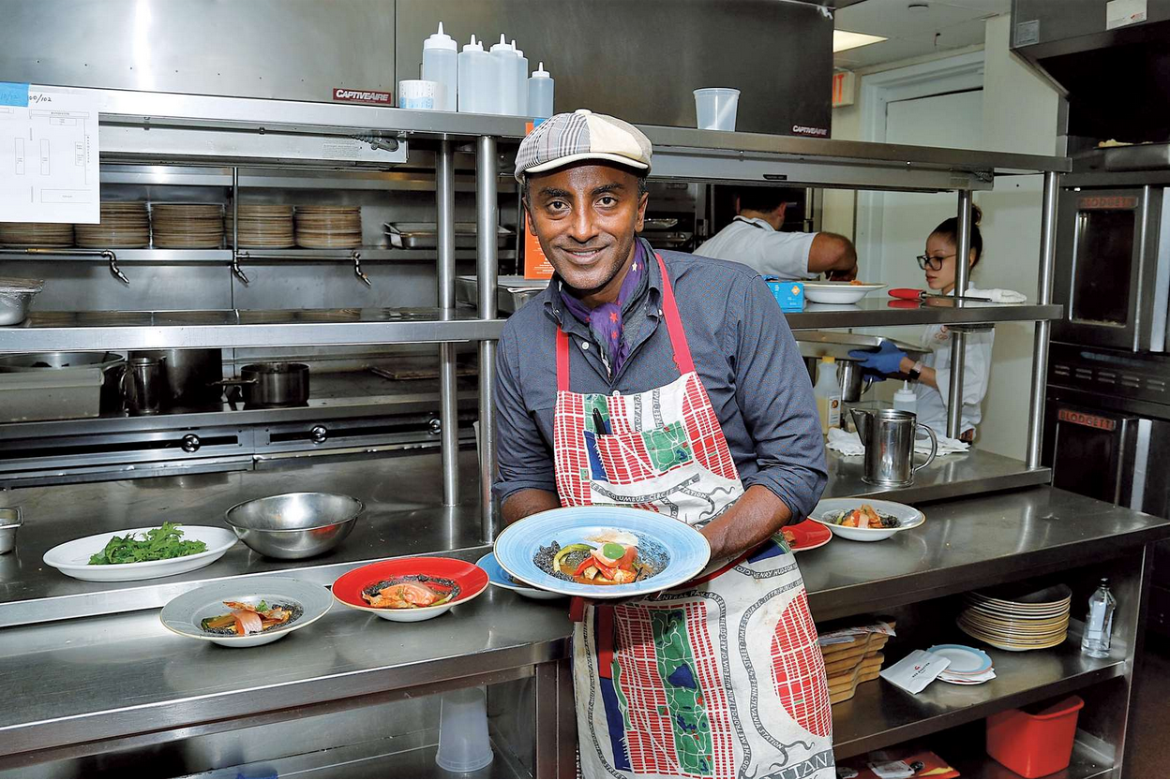
Part 3: Harlem success stories

Doc 1: Listening comprehension.
“I got nervous before I cooked for President Obama”.
- Listen to the recording and give information about the man (name, country of origin, job)
- What happened to him after the attacks on September 11th?
- Explain how the Red Rooster restaurant reflects Harlem’s culture.
- Make a list of the man’s achievements.
- What do the figures 24, 6, 7 and 20 correspond to?

Doc 2: Instagram : Kibonen Nfi, Kibonen.ny, 2018
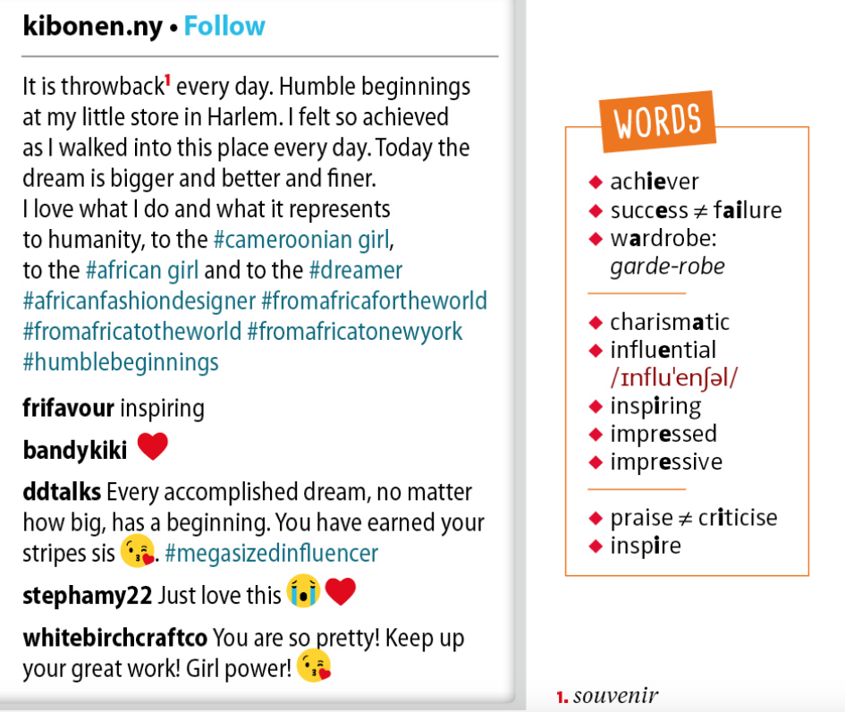
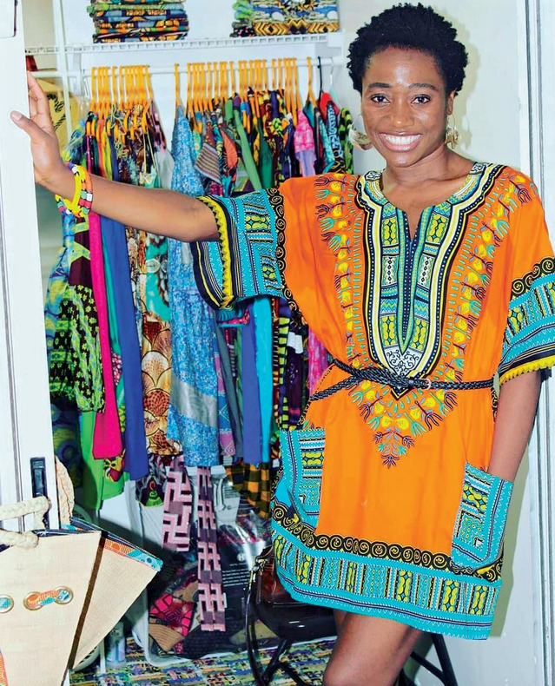

- Look at the picture and comment on the Kibonen’s clothes and attitude.
- Guess where she is. Then read the text and check your hypotheses.
- Grammar: Observe these words: bigger, better, finer. Comment on their form.
- Focus on the hashtags. Say what information they give about Kibonen and her goals.
- Focus on the tweets. What do the expressions “inspiring”, “you have earned your stripes”, “keep up your great work”, mean? What do they reveal about Kibonen?

