NOTION: The idea of progress VIDEO TIME: DIGITAL DETOX CAMP

MISSION 1 : Read and complete with the help box…
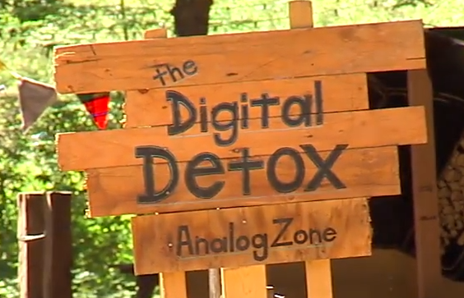
addiction - laptops - digital detox camps - bad habits - hooked on* - spend so much time on
Many of us are now ______________ digital devices, from smartphones and tablets to ________________ and TVs. In fact, some of us _______________________ digital media that we develop symptoms of __________________. But now, worried people are signing up for* ________________________, to try and wean themselves off* their _________________. So we sent our local correspondent to join them for some technological cold turkey*.

MISSION 2 : Complete the following grid, vocabulary of ADDICTION…
cold turkey |  | To wean somebody off something
To go cold turkey |  | To be cold turkey
To be hooked on |  | To sign up for

sevrer quelqu’un de quelque chose/sevrage brutal/décrocher/s’engager dans /être accro à/être en manque

MISSION 3: VIDEO TIME: Digital Detox Camp
Part 1: (0.00 to 0.35)
Name of the place: Location:
What?
INTERDICTIONS: 1. _________________________________ is forbidden.
2. _____________________ is not allowed.
3. _____________________ is impossible.
Part 2: (0.35 to 1.16)
Campers HAVE TO put all their digital devices _______________ and _______________ _________________ in a room.
When you leave the room you neither have___________, _____________nor __________.
What have you got left?
How old are the campers?
Do they keep their names during the session? WHY?

Part 3 : (1.16 to 2.12)
TO REPLACE digital communication, campers can 1.
2.
To scroll = faire défiler a news feed = un fil de nouvelles
3.
4.

WHY did Levi Felix create his digital detox camp ? EXPLAIN

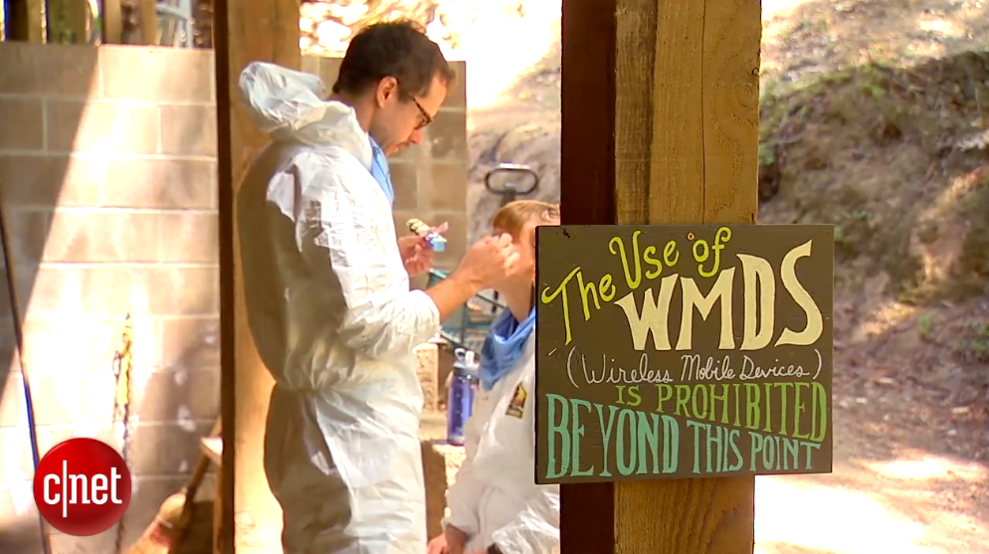
HIS CAMP OFFERS :

PURPOSE : It’s a digital detox center, not a REHAB* (centre de désintoxication) WHICH _______ _____________________________________________________________

COST of the stay: COMPLETE

Camp Grounded costs $ _ _ _ for __________________ including ________________, batteries not ________________ or _________________

