NOTION: The Idea of Progress WITH or WITHOUT Technology?

MISSION 1: A survey / What do you know about technology use around the world?

- Which country has the highest percentage of its population connected to the Internet?
The USA India China Iceland

- What is the percentage of people who do not have access to Internet in the world?
20% 35% 60% 80%

- Which country is the largest consumer in the world?
China (since 2010) France Ghana The USA

- How many electronic devices (smartphones, tablets, laptops; etc…) does an average British household own?
3 7 10 13

- What is the percentage of American households without a TV set?
5% 20% 45% 60%

MISSION 2: LISTENING COMPREHENSION / The digitally excluded

Listen, TAKE NOTES and try to answer these 5 questions in French…then recap in English with your teacher.

HELP: to launch = to tackle the issue =
to dodge the issue =
to confuse the issue =
- What is “digital exclusion”?
- Pick out the numbers you heard and say what they correspond to.
- Who are the “most digitally excluded” groups and why are they unconnected?
- What are the benefits of being connected?
- What initiative was launched to tackle the issue?

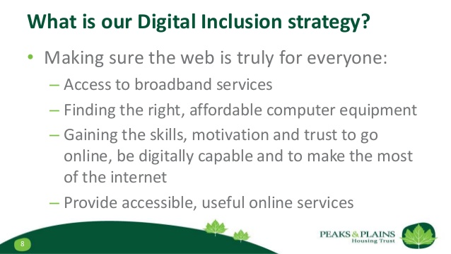
TRANSLATE:
Ce podcast présente la notion d’« exclusion digitale » en Grande-Bretagne et montre qu’une partie de la population britannique n’a pas accès à Internet, essentiellement par manque de compétences ou de revenus. Heureusement, depuis 2014, le gouvernement anglais s’attaque au problème et il a décidé de lancer et financer un programme pour permettre aux personnes âgées ou défavorisées d’acquérir les compétences nécessaires pour surfer sur internet.

MISSION 3: Disconnected by choice: the Amish

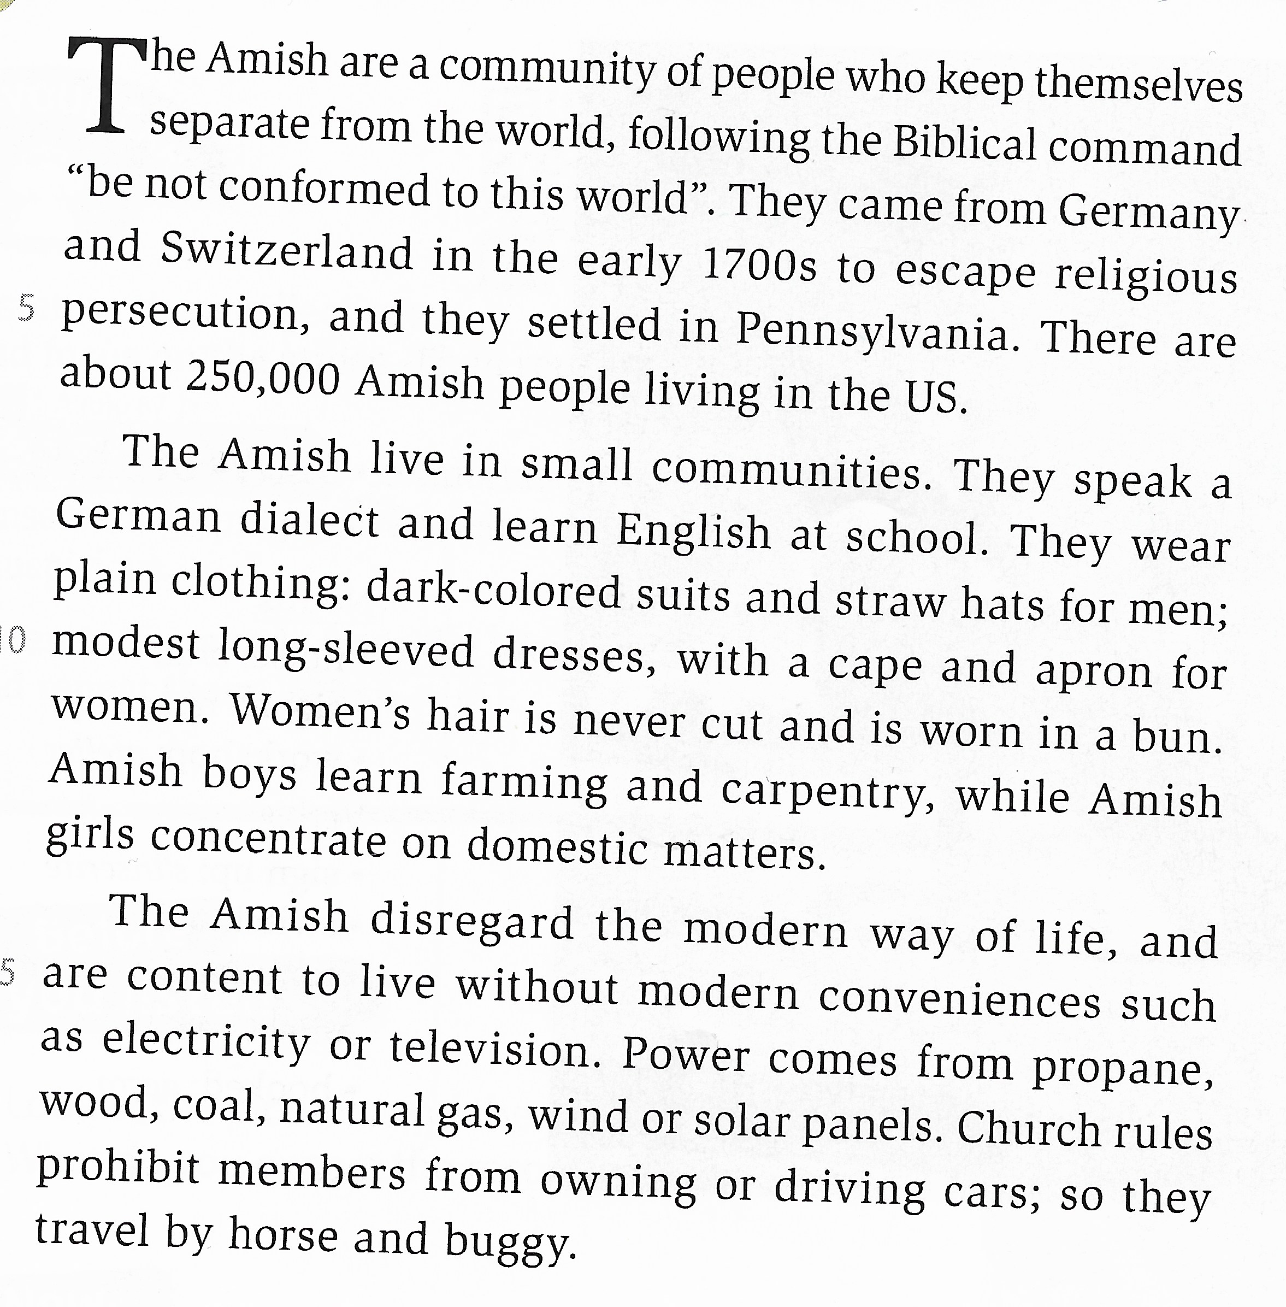
A.Read AND find the following information:

Religion:

Language:

Transportation:

Living conditions:

Clothing and hair:

Employment:

AT HOME: Learn more about the Amish here…
http://florenceconrard.over-blog.com/2016/09/the-amish-can-we-say-no-to-progress.html

B. Find the equivalents in the text for these words:

S’installer = Simple, uni =
Chapeau en paille = À manches longues =
Un tablier = Un chignon =
Ne pas tenir compte de, être indifférent à = Une calèche =
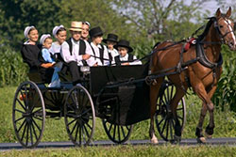

How do the Amish look in our eyes?

C. Discuss the PROS and CONS of living in an Amish community

Pros Cons

