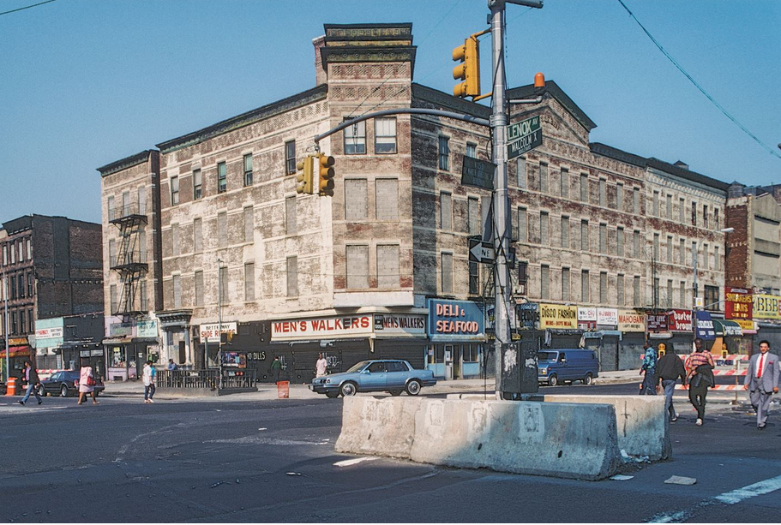
PART 2 : Gentrification

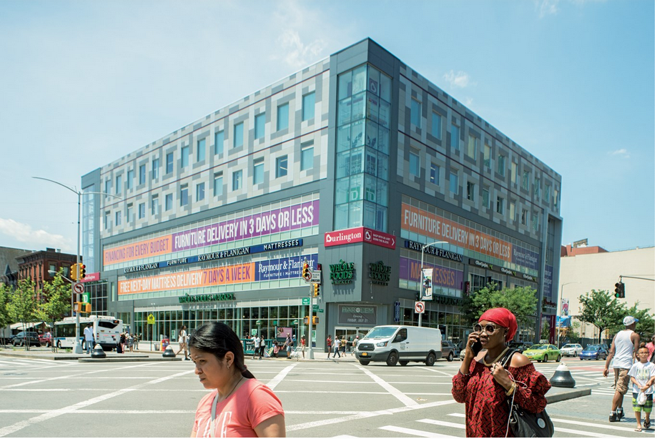
Definition: The process by which a place, especially part of a city, changes from being a poor area to a richer one, where people from a higher social class live.
The corner of 125th Street and Malcom X Boulevard in 1989 and 2017.
2017
1989

= ………………………….

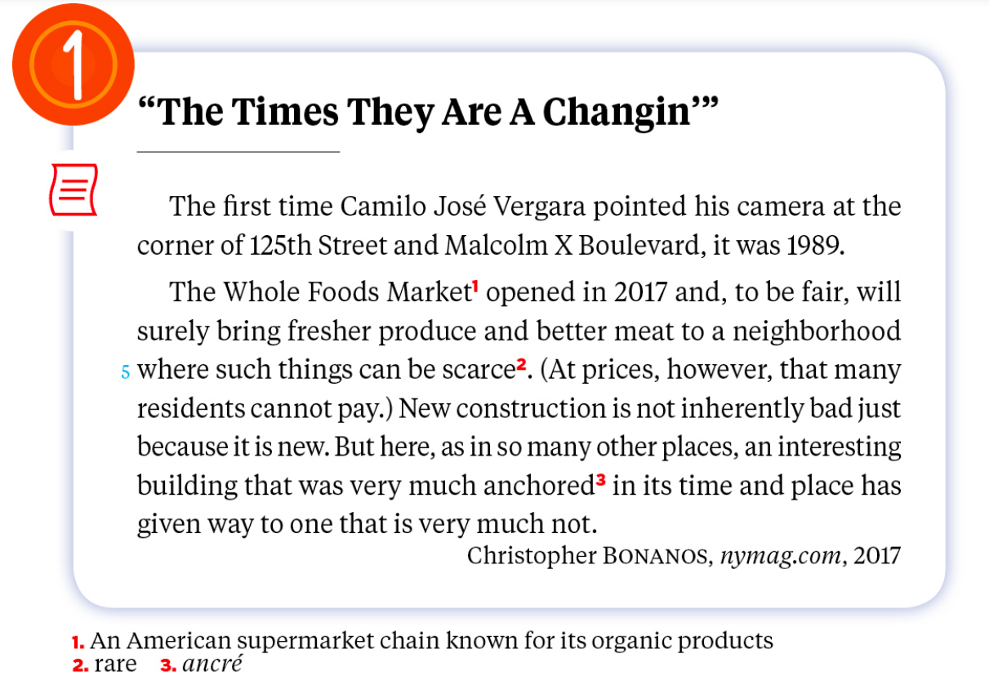
Doc 1 : « The Times They Are A Changin’ »

a.Look at the photos, read the text and comment on the evolution of the building.

b.Say what is positive and negative about the arrival of Whole Foods Market in Harlem.

c.What is the journalist’s feeling about this change ?

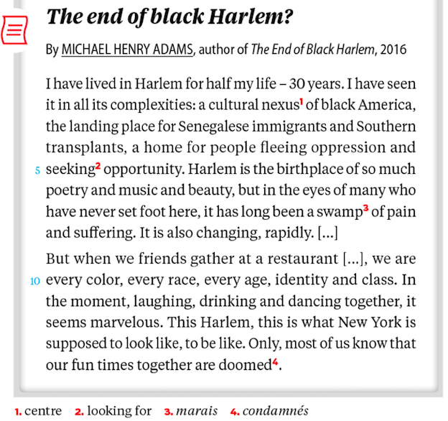
Doc 2 : The end of black Harlem ? The rift (fissure) between the old and the new Harlem
- Read the text and introduce it. Who is the narrator? What is the main issue?

- Pick out elements showing the complexity of Harlem.

- Focus on: “It is also changing, rapidly”. Comment on the use of be+V-ing.

- Read the last paragraph and explain what the author feels about Harlem and what he fears.

