FEED 1 : LIVING IN A SECOND WORLD KEY QUESTION: How can social media affect teens?

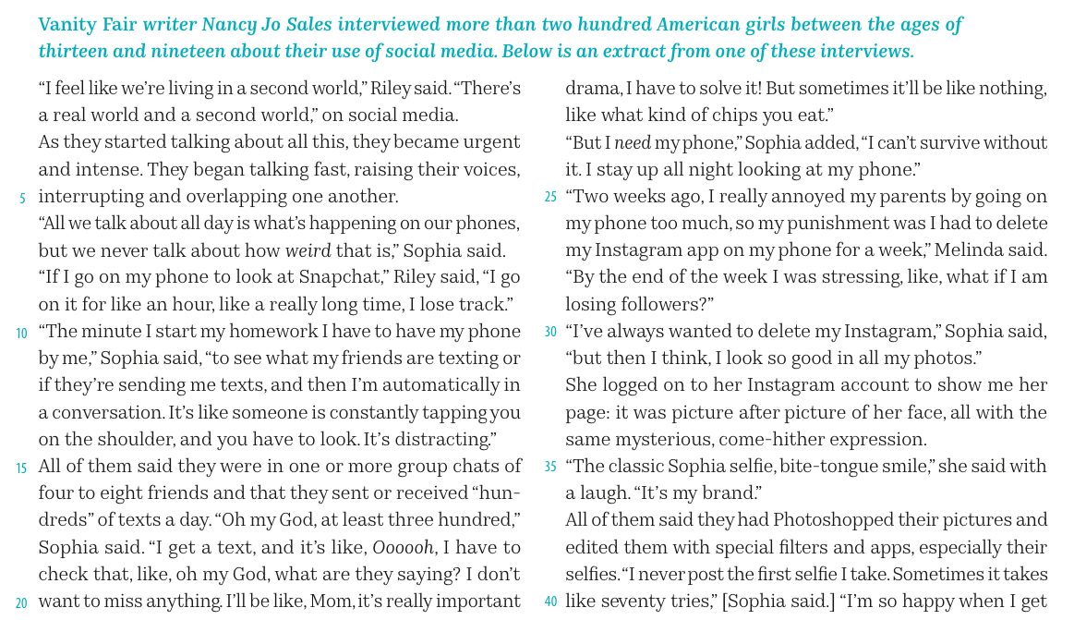
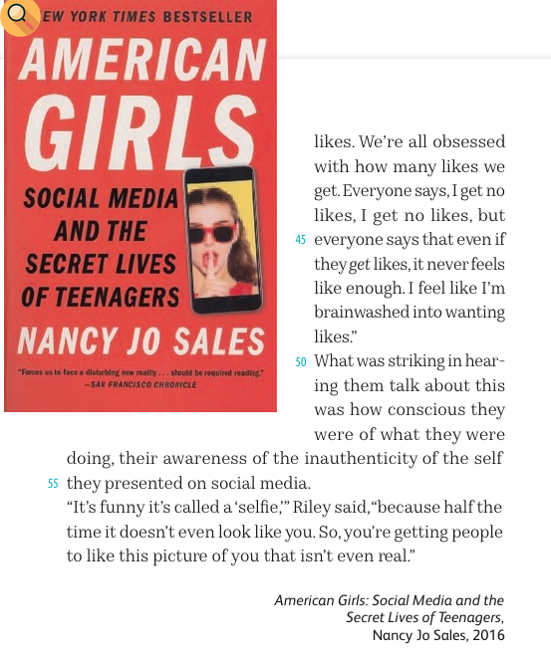
MISSION 2: Reading Comprehension

READ THE TEXT

- Focus on these teenagers’ emotions when they use social media. What problems does it reveal?
- Explain what “the second world” is.
- Are there disadvantages to being on social media?

DRAW A CONCLUSION
- What are the similarities and differences between the characters in the two documents? (Cartoon + text)
- Do you see yourself in these characters?

