IS THE FUTURE NOW ?

Dystopia: an imagined world or society in which people lead wretched, dehumanized, fearful lives.
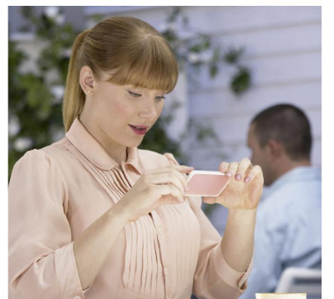
MISSION 1: Look at the comic book cover and the photo
- What rating system do the stars remind you of?
- Focus on the woman’s face and explain how she is feeling?
- Watch the featurette and explain what you have understood.
Black Mirror’s episode “Nosedive” as a pulp comic book cover, Butcher Billy, 2016
Lacie (played by Bryce Dallas Howard), the main character of Black Mirror’s “Nosedive”.

MISSION 2: LISTENING COMPREHENSION: Your reactions to Nosedive Take notes focusing on the following categories
 | DANGERS | BENEFITS
The world of Nosedive
Our world

Would you say, like the creator of Black Mirror, that “Nosedive” is “the world we live in”?

