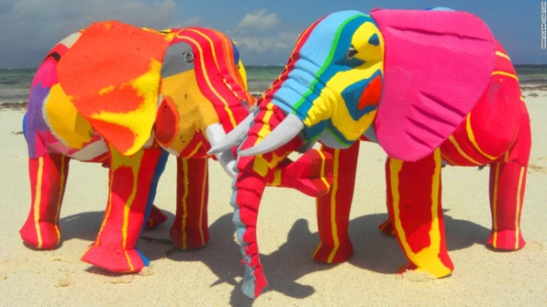
FROM TRASH TO ART

MISSION 1: EXPLORE
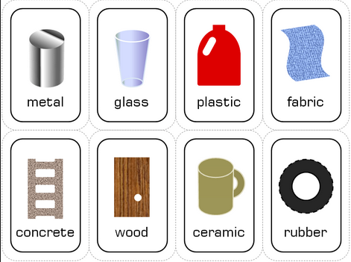
- Look at the photos and imagine what these objects might be made of.
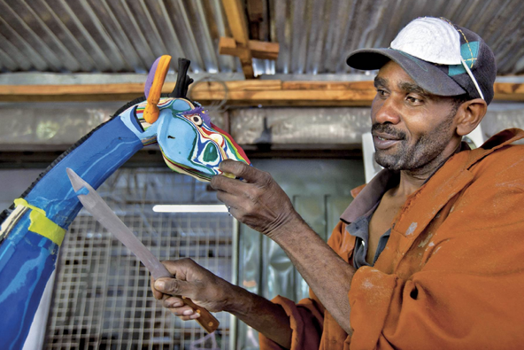

- Fill in the blanks with one of the following verbs:

scratch – break – stretch – bend – squash – soak up

When something is:
a) flexible, you can ____________ or _______________it.
b) hard, you can't ____________ or ______________it.
c) absorbant, it ________________ water.
d) brittle, you can easily ________________ it.

- Talking about materials. Find the corresponding French equivalents:

flexible | elastic | bending | malleable | solid
stiff | hard | inelastic | firm | soft
MISSION 2: VIDEO TIME
- Watch the video, check your hypotheses and pick out more information about the project.
Focus on:
- The type of artwork:
- The material used:
- The origin of the project:

- Reorder the different steps of the project and use the verbs to rephrase the process

carve collect glue sell wash

- Focus on the places mentioned and say what they correspond to:

PARIS

NAIROBI

INDONESIA

AMERICA

- Comment on the impact of the project
- In the country:

- Abroad:

- Explain who Dan Wambui is and how he feels about the project?

MISSION 3: Do research on Ocean Sole and recap the information.

