MISSION 2 : KENYA CONSERVANCY AND TOURISM LISTENING COMPREHENSION
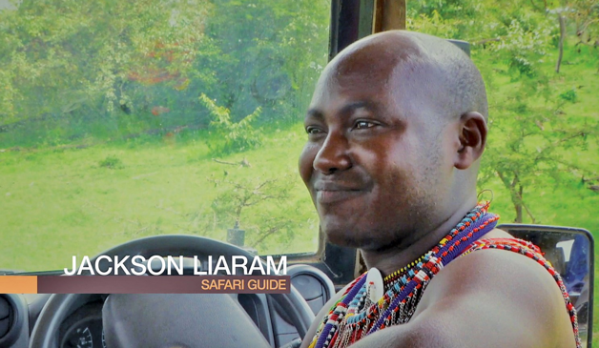
- Listen to the recording. Find information about the new role given to the Maasai.
- Explain how much it benefits the community
- PHONOLOGY: Listen to these words from the video: migrating, visiting, rapidly, firstly, increased, employed.
Find the root words and the suffixes: does the suffix modify the stress?
Example: migrating = migrate + -ing

MISSION 3: THE GREENHOUSE PROJECT READING COMPREHENSION
Background information:
The Sauti Kuu Association was founded by Dr. Auma Obama, Barack Obama’s half-sister. This organization supports children and adolescents in their actions to become independent and financially autonomous in Kenya, but also in Germany. The projects presented here show how local initiatives can help people become more independent.
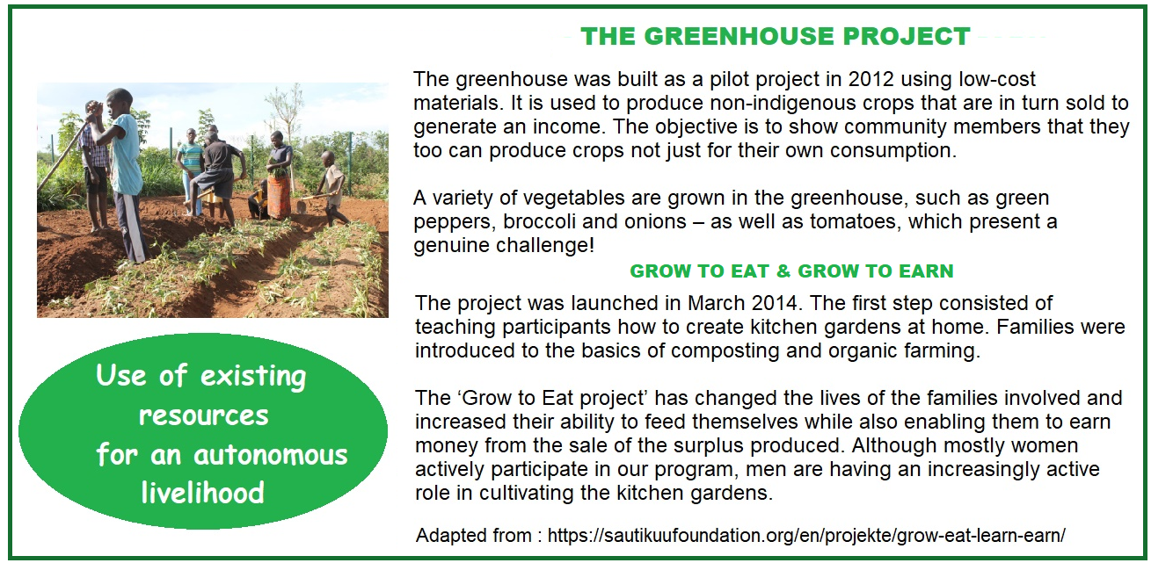

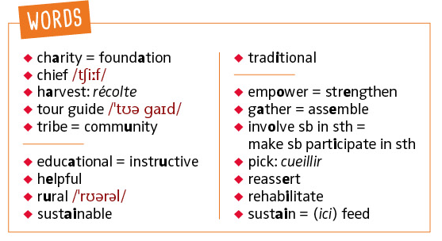
- Look at the document and identify the basic elements: type of document, name and type of organization.
- Read about the projects and explain what they consist in.
- To what extent can these projects help the local population?
- COMPOUND WORDS: green house, kitchen garden, low-cost, non-native.
Detail how they are composed. Give a definition of greenhouse and kitchen garden.
Now go on the Sauti Kuu website and learn more about this organization
https://sautikuufoundation.org/en/startseite-en/

