First, a definition… What is art for you? ART…

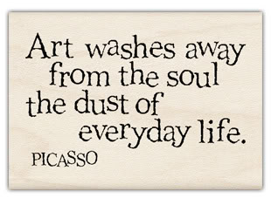
“Art is powerful. Art is meaningful. It enriches our society”. Keith Bond (Fine Arts Artist)
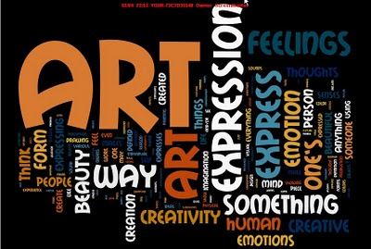

What types of Art do you know? (fill in the grid and add more if you find some)

Une peinture |  | Une gravure sur bois
Un autoportrait |  | La mosaïque
Une nature morte |  | La poterie
Un croquis |  | La sculpture
Une bande dessinée |  | La céramique
Un dessin humoristique |  | La photographie
Un dessin |  | L’architecture
Une gravure |  | Le design (objets, vêtements…)
L’art de la rue |  | L’art numérique
Les beaux-arts |  | La musique
Les arts graphiques |  | Le cinéma
Les arts appliqués |  | Le théâtre

Which one(s) is/are your favourite and why?

TOOL BOX:
fascinating, enthralling, necessary, useful, helpful, creative, interesting,

powerful, meaningful, expressive, moving, touching, stirring, affecting…

VIDEO TIME https://www.youtube.com/watch?v=GkY3uNK9SIc

Listen, take notes and be ready to summarize what you have understood in 60 to 100 words.

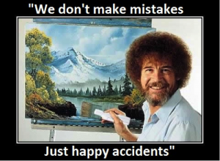

FINAL TASK: WRITING (150 words)
What’s your favourite kind of ART? What would be your life without Art? Why?

