NOTION: PLACES AND FORMS OF POWER
A NATION OF GUNFIGHTERS

KEY ISSUE: Why do Americans love guns and what is the social cost of gun ownership?

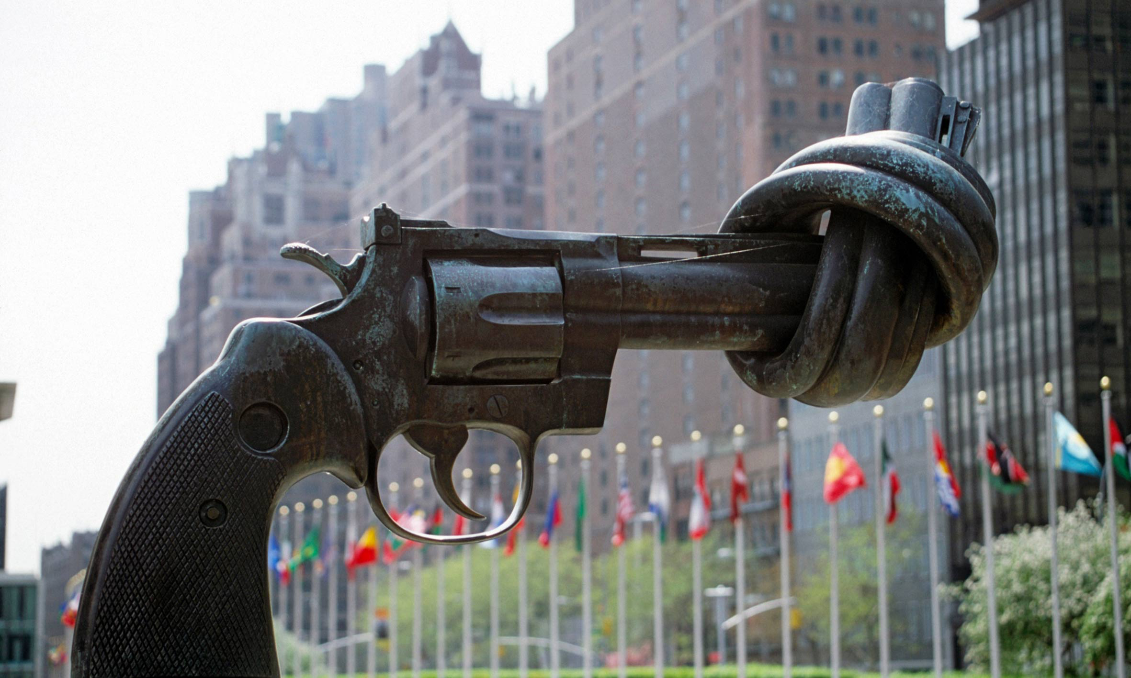
MISSION 1: Which words come to your mind when you see this sculpture?

MISSION 2: DISCUSSION: What do you know about guns in the USA?
Non-violence, bronze sculpture by Carl Fredrick Reuterswärd in 1987, United Nations Headquarters, New York.

----------------------------------------------------------------------------------------------
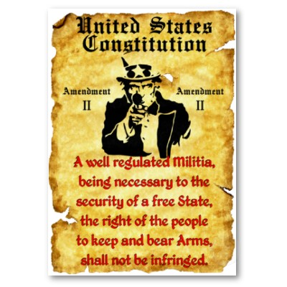
MISSION 3: Basic gun facts

- Say what the picture shows. Complete:
This is the Second Amendment to the ……………………………..
…………………………….. .

- What does the II Amendment say ?

TO INFRINGE A RULE =

3. Explain what a « militia is » ?

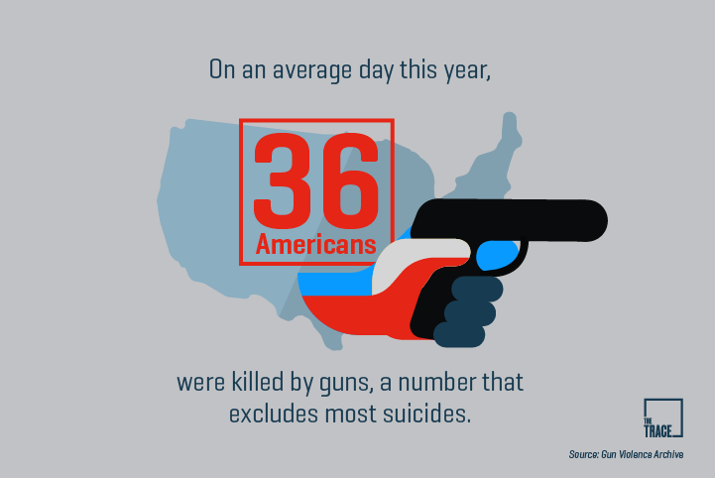
4. Fill in the blanks with the right figures :
100,000 – 20 times - one million – 30,000
The firearms homicide rate in the US is ______________ higher than in other rich countries.
On average, more than _________________ people are shot each year and ________________ of them die.
More than ___________________ people in the US have been killed with a gun since 1968, when Dr Martin Luther King Jr was assassinated.
MISSION 4 : A very powerful lobby Listen to the recording and report about the National Rifle Association of America (NRA):
- a definition
- what they want.
- what they provide
- their arguments (3 arguments)
- what they do to counterbalance (compenser) their position
- their mode of action
----------------------------------------------------------------------------------------------
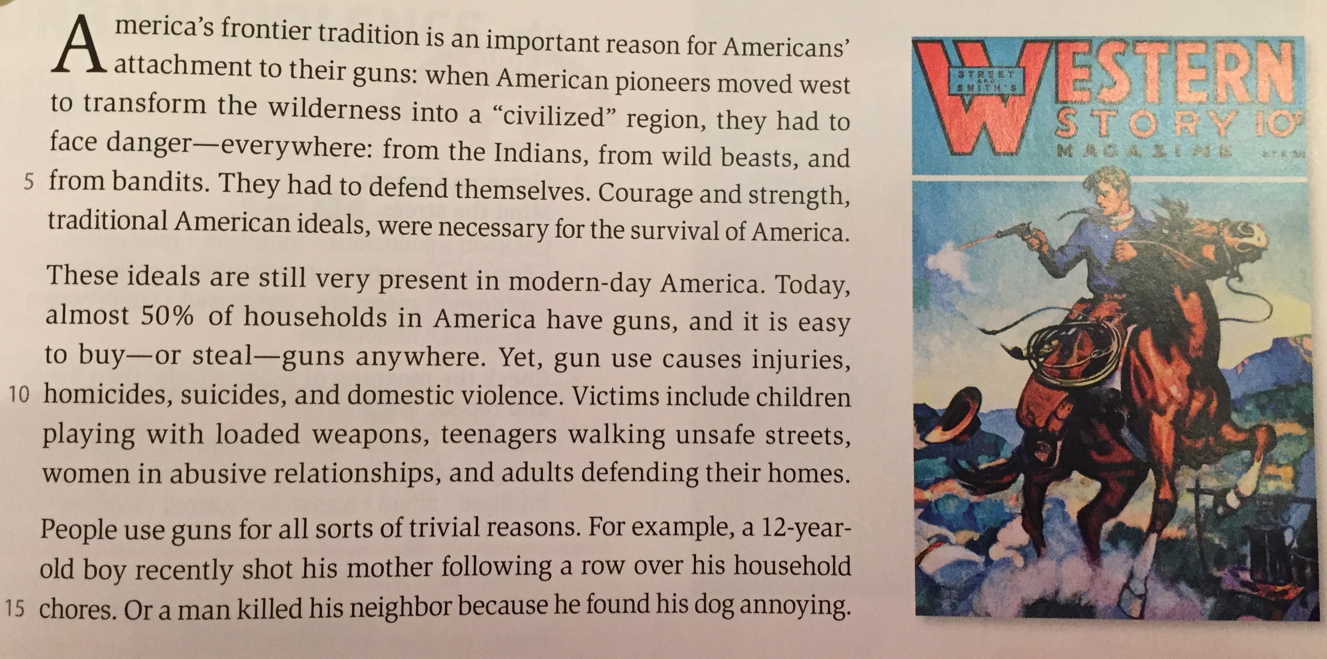
MISSION 5: READ and UNDERSTAND

- What are the traditional American ideals quoted?
- State the consequences of guns being everywhere.
- Pick out the two examples of gun use for trivial reasons.
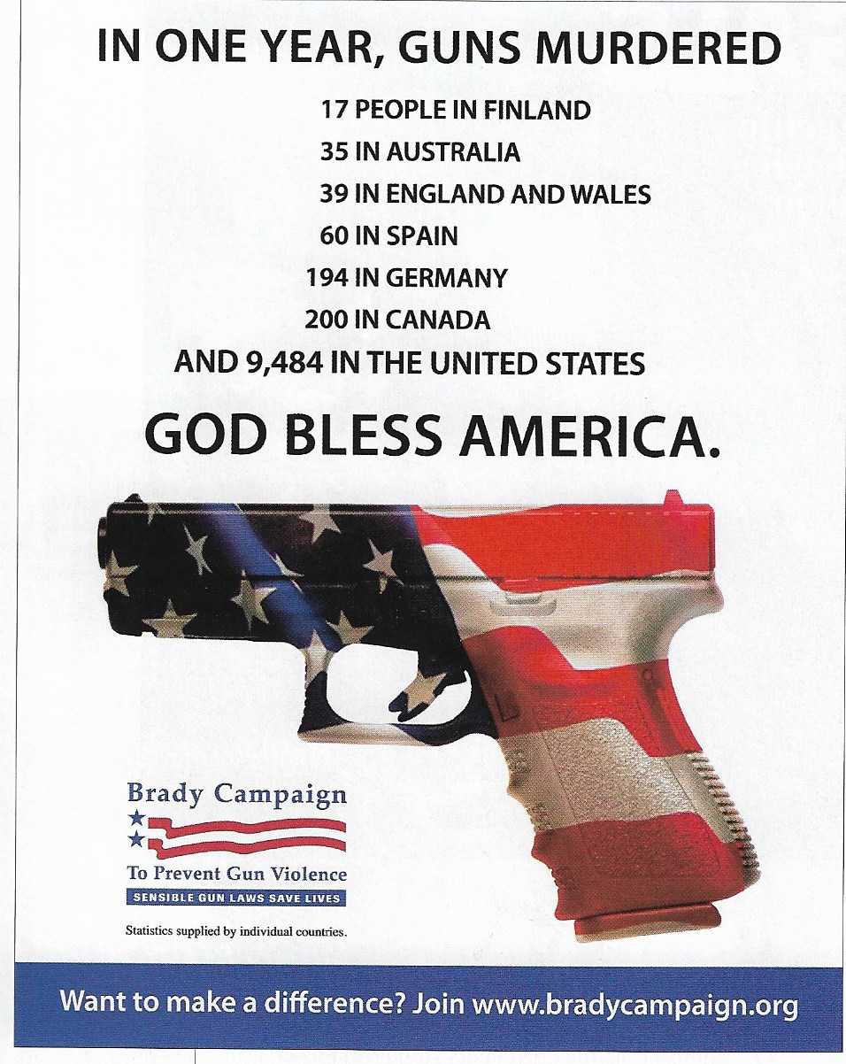
- Give the equivalents:
un espace sauvage =
force =
survie =
un foyer =
blessures =
une dispute =
violent =
violences conjugales =
armes chargées =
sans importance, insignificant =
corvée ménagères =
pénible, agaçant =

MISSION 6: Gun crime statistics. 1. say what the statistics show 2. explain the goal of this poster
RECAP : Complete the following text with the given words
anybody / patriotic / awareness campaign / murdered by / easy access /
ashamed / on the other hand / God Bless America / higher rate / aims at /
notice / American flag / less than / pointing out / ironical /

This poster shows the number of people _______________ guns in one year in various countries around the world. We can _______________ that most countries have ___________________a hundred gun murders a year. The US,________________ , has an incredibly ___________________ with nearly 10,000 people murdered with guns every year.
In the middle of this ______________________ , we can see a handgun with the colours of the ____________________ and the slogan “_________________”. Considering the statistics, we understand that this slogan is ___________________because the poster shows nothing to be _____________about. On the contrary, these numbers reveal that the US should be _______________and try to change things.
This campaign obviously ________________ fighting gun violence in America by ____________________the high gun murder rate in the US in contrast with other countries around the world. It might denounce the ______________ to guns in the country and the fact that ______________ can walk into a store and get a gun.

