Written Comprehension WORKSHEET

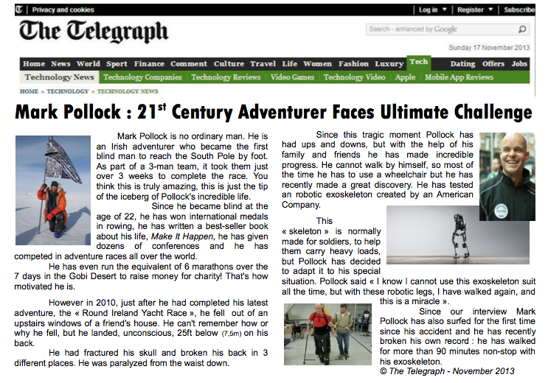

**Read and write complete sentences about this document:**

(type, source and date)

(title)

(subject) It …………….. with ☐Mark Pollock’s ordinary life ☐Mark Pollock’s extraordinary life

PART 1: READ from the beginning to “from the waist down”

A. Say whether these statements are true of false and justify by quoting from the text.

1. Mark walked to the South Pole T F : “……………………………………………………………”
2. He did this record on his own T F : “……………………………………………………………”
3. He was born blind T F : “……………………………………………………………”

B. What makes him an extraordinary man? What has he already accomplished in his life?

1.

2.

3.

4.

5.

C. Find the English equivalents for:

atteindre: terminer une course: la pointe de l’iceberg:

depuis: l’aviron: des douzaines de:

participer à: récolter des fonds: une association caritative:

D. What tragic event happened to him in 2010?

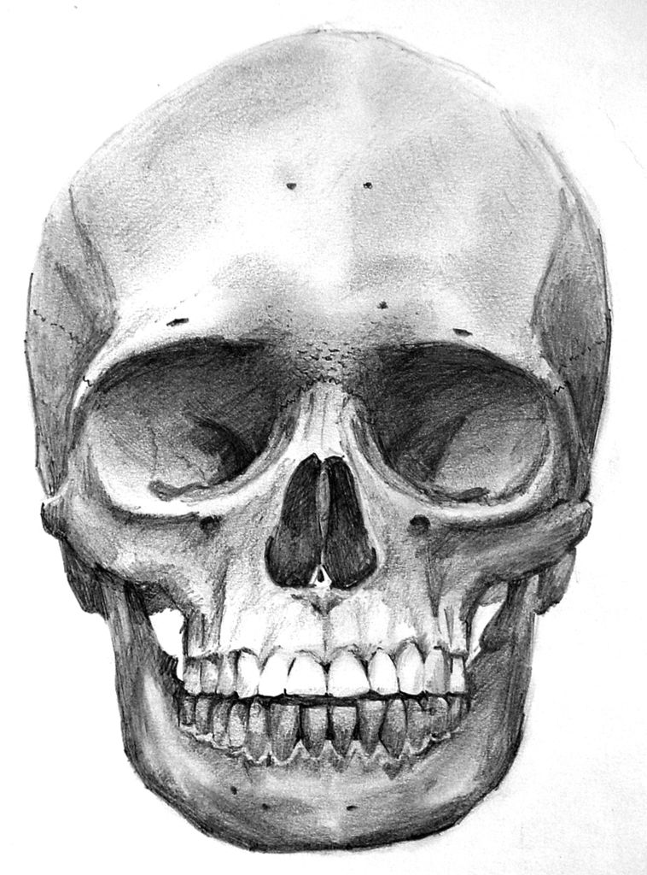

E. Physical consequences: His skull was …………………… A SKULL

His back ………………………..

His body ………………………..

From the context, what body part is “the waist”? ☐la hanche ☐le poignet ☐la taille ☐la cheville

Conclusion:

PART 2: Read the second column of the newspaper article

A. Quote the sentences indicating that:

a. Mark Pollock has been through good but also difficult moments.  to go through= traverser

b. He needs help to move.

c. He has found a high-tech solution to help him walk.

B. What sports performances has Mark achieved thanks to the exoskeleton?  to achieve = accomplir

a.

b.

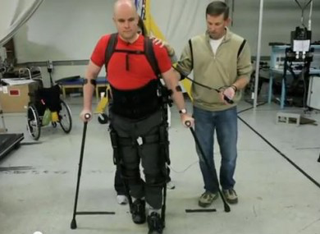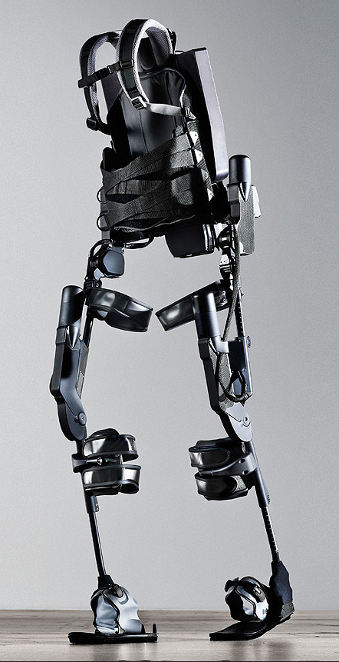

Learn more about the exoskeleton:

The main function of a powered exoskeleton is to assist the wearer by boosting their strength and endurance. They are commonly designed for military use, to help soldiers carry heavy loads both in and out of combat. In civilian areas, similar exoskeletons could be used to help firefighters and other rescue workers survive dangerous environments.

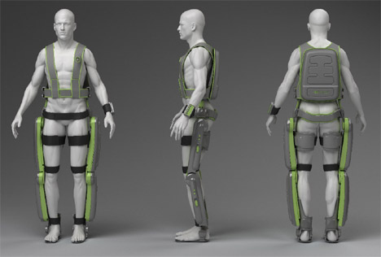

**The American « ReWalk system »**

**It’s not just walking – it’s More Than Walking**

ReWalk is a wearable robotic exoskeleton that provides powered hip and knee motion to enable individuals with spinal cord injury (SCI) to stand upright, walk, turn, and climb and descend stairs.