[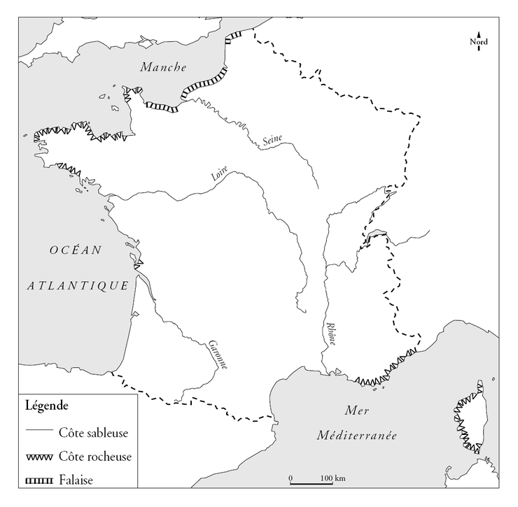](https://www.google.fr/url?sa=i&rct=j&q=&esrc=s&source=images&cd=&cad=rja&uact=8&ved=2ahUKEwiT_Kv9v73eAhVIyYUKHVXXDDYQjRx6BAgBEAU&url=https%3A%2F%2Fwww.assistancescolaire.com%2Fenseignant%2Felementaire%2Fressources%2Fbase-documentaire-en-geographie%2Fle-littoral-francais-fde10es15i02&psig=AOvVaw3Vt139zqDGcF1XaQfxkaHG&ust=1541515787613296)