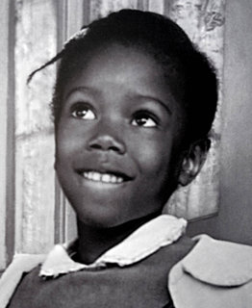
The story of Ruby Bridges.
http://www.youtube.com/watch?feature=player_embedded&v=mWW7vrtM-sY#

- Right or wrong? Watch the video and complete this chart.
Right or wrong?
Her story takes place in 2009
The video is about a film
In 1960, black children and white children went to the same schools
The name of the little girl is Ruby Bridges
She was the first white child to go to an all black school
The parents of the white children were happy to see Ruby Bridges
Ruby Bridges spent only one week alone with her teacher, Mrs Henry
She was happy when the white children came back to school
Ruby Bridges says she did not feel alone
She says it doesn't matter what you look like
She is here to promote her book

- Listen again and fill in the blanks with the missing words.
A long time ______, some people thought that _______ people and white people shouldn’t be ________. In some places white children and black children couldn’t go to the _________ schools. I am Ruby Bridges today and I am _________ that I helped to _______ that.
In ___________, I went to kindergarden in an all black school. I liked my school, I liked my teacher, I liked my friends. But there was a school for __________ children even __________ to my house. And the ___________ said “Ruby Bridges should be _________ to go to that school.” So, when I was in first grade, my mother took me to the all white school. Some people didn’t want me there and the _______ came with us just to make sure we were _______. Even parents had their children ______ of school just because I was there. I was _________ with my teacher, Mrs Henry. Months and months passed, and then, one day, children began to come _________ to school. At last, I had ________ to play with. Boy, was I happy! Now, black kids and white kids can be in the same school __________.
I ________ all kids should be friends. All you have to do is give each other a ____________. And hopefully my ________ will help you to reach out to other kids, to give them a chance, so we could be friends and no one will feel like I felt in 1960, when I was _______. Mrs Henry and I gave each other a chance. We were friends then and we are still friends today. It doesn’t matter what you look like. What matters is what’s __________, so I encourage you to get my book, _________ it with a friend. Surely you’ll enjoy the story and, hopefully, make a friend for life.

- What do these words mean in French?
Kindergarden: ________________ be allowed to: ______________
Make sure: __________________ safe: _____________
Even: _______________ alone: ______________
The same: _____________ hopefully: ______________
Still: ____________ look like: ____________
Inside: _____________ share: _________________

