THE AMERICAN CIVIL RIGHT MOVEMENT
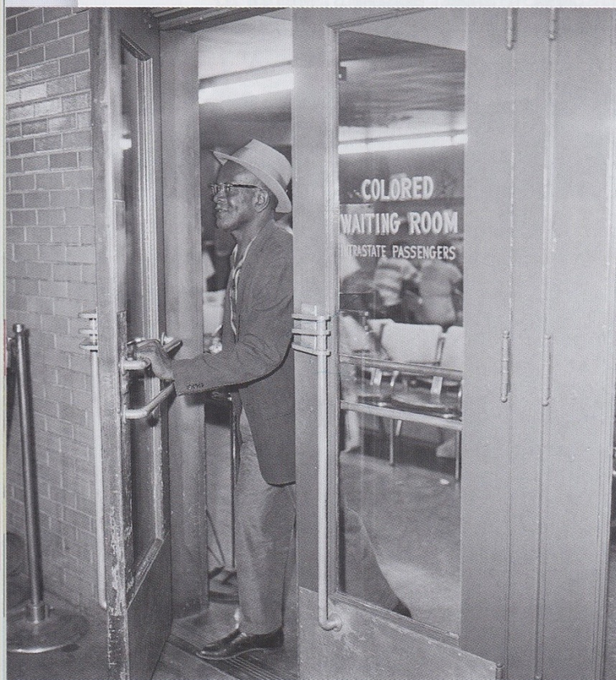
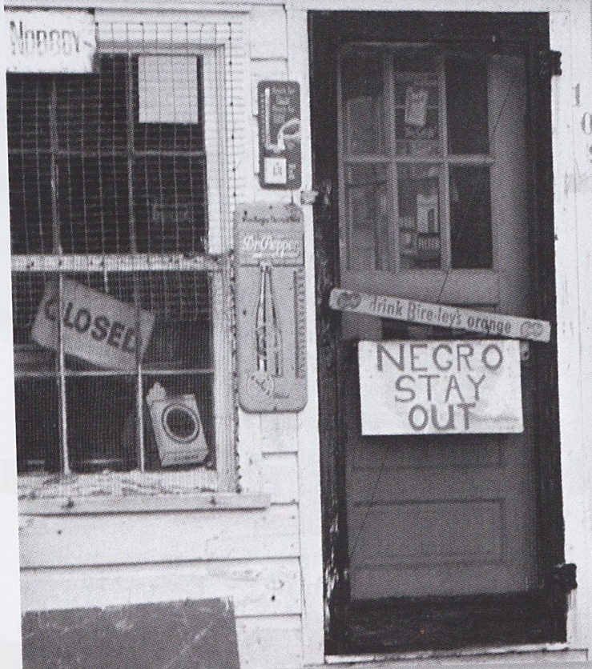
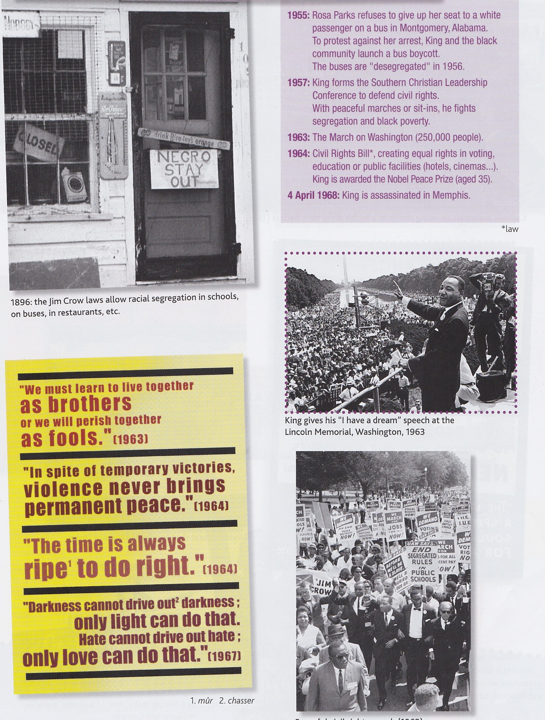
1896 : The Jim Crow laws allow racial segregation in school, on buses, in restaurants…
A « colored waiting room » at the bus terminal in Jackson, Mississippi.
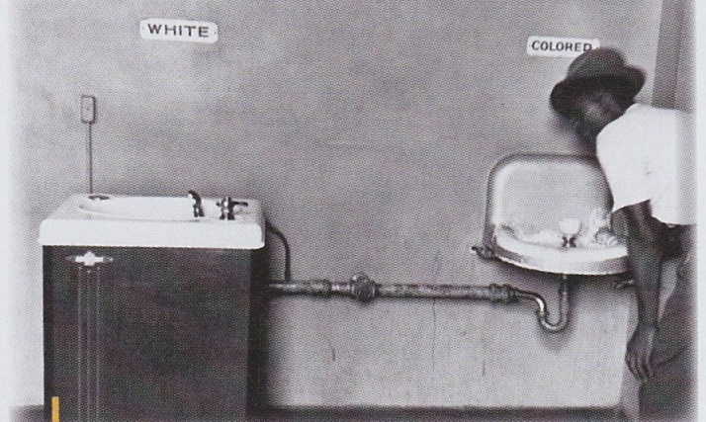
King gives his
« I have a dream » speech at the Lincoln Memorial, Washington, 1963.
Segregation in 1951, in Atlanta, Georgia.

“I have a dream”, Martin Luther King, 1963 – Washington, 100th anniversary of the Emancipation Proclamation

« I have a ___________ that one _________ on the _________ hills of Georgia, the _________ of former ___________ and the sons of former slave ________ will be able to _____ _______ together at the table of __________ …. I have a _________ that my ________ little __________ will one day __________ in a nation where they will not be judged by the _________ of their __________ but by the content of their ___________ … When we let ___________ ring, when we let it ring from every ___________ and every hamlet, from every _________ and every __________ we will be able to speed up that day when all of God’s ________, __________ men and ___________ men, ______ and Gentiles, ___________ and ____________ will be able to join ___________ and _________ in the words of the old Negro ____________, ‘_________ at last! Free at last! Thank God Almighty, we are free at last!’ ” http://www.youtube.com/watch?v=8ryy7eP0kks

