https://barodevel.com/la-cave-cooperative/

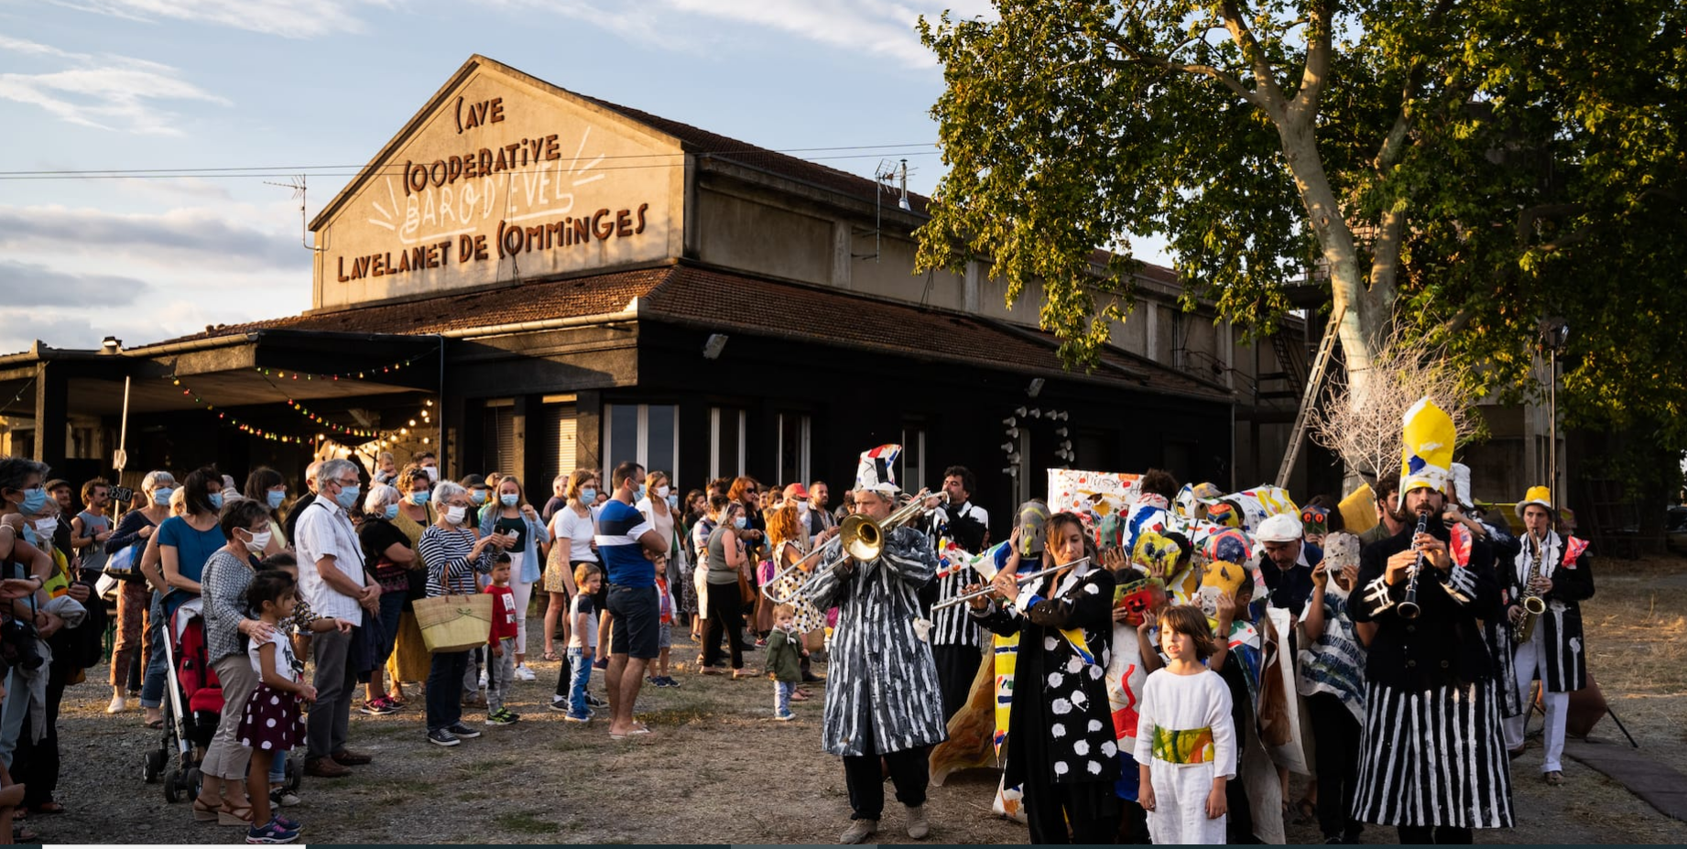
Les «artistes» complices de la mascarade covidienne.

